Automated Paint Mixing Machine with Color Detecting Mobile Application

Jerico M. Clemente1, Aldrin O. Dizor2, Marife G. Gajelan3 , Joven R. Sabangan4

1Department of Computer Engineering/ Research Institute for Science and Technology, Polytechnic University of the Philippines, Philippines (Jerico M. Clemente, Aldrin O. Dizor, Marife G. Gajelan, Joven R. Sabangan)

2Department of Computer Engineering/ Research Institute for Science and Technology, Polytechnic University of the Philippines, Philippines

3Department of Computer Engineering/ Research Institute for Science and Technology, Polytechnic University of the Philippines, Philippines (Julius S. Cansino, Arvin R. De La Cruz)

***ABSTRACT***

*Colors have been used to communicate actions and influence certain physiological responses from different organisms around the world. With the advancement of science and technology, humans have developed paint, which served as a means to acquire and artificially apply color to different objects and surfaces. Therefore, this study aims to establish an effective system that will simplify the process of mixing paint colors in order to produce a desired color output. In order to create the system, the proponents developed both a machine and mobile application. An image was captured through the application, and the corresponding selected color value is then sent to the machine for processing. The output products of the system are then compared against the actual color value, where accuracy is measured. The system itself is then evaluated by ordinary users and technical specialists via a questionnaire based on the ISO 25010 standard. The accuracies of the mobile application’s color scanning capability, and the output paint color were calculated to be at least 98% and 80%, respectively. Based on the results of the study, both types of respondents gave a generally agreeing score based on the characteristics in the ISO 25010 standard. The mobile application performed satisfactorily as well, and the difference in camera resolution were minute. Furthermore, the output paint color perceived by the users were given an average score ranging from slightly similar to neutral, indicating that the colors were satisfactorily the same.*

**1. INTRODUCTION**

Colors are used as a form of communication to invoke different emotions or signs in the readers. It can be used to distinguish between nearly identical objects, such as those from a traffic light, and signal a different meaning. The human eye can differentiate exactly three different colors; however, the brain can interpret these in multiple ways. A typical application of using colors is paint — which is essential in giving color to one's room. It also provides a protective coating that preserves either or both exterior and interior surfaces. This helps the surface where paint is applied to withstand erosion while at the same time protecting it from damages that extreme weather conditions may cause. Another importance of paint is that it helps set the mood for someone in the room seeing it. It is said that rooms with light-painted walls tend to put people in a happier mood instead of rooms with dark-painted walls that negatively affect people's attitudes. Therefore, determining the right color for the context will help convey the correct meaning and avoid misunderstandings.

The paint mixing process has been steadily improving ever since fred a. Schletz invented the paint-mixer in 1932, which was then called the "shakers." (peiken, 2003) as the world continues to evolve, many paints mixing machines have also surfaced on the market. However, paint mixing is an entirely different process compared to color picking. Color picking is crucial when someone wants to choose a specific color or shade for their surface; hence making one slight error may compromise the whole process. This can be avoided with the help of technology in the form of a digital color picker — which people will be able to utilize by using their smartphones.

Smartphones have changed people's lives. And as time goes by, this revolutionary technology keeps getting more innovative and better. With the use of mobile applications, smartphones can do almost everything. With the advancement of technology and the dominance of the smartphone industry, mixing paint colors to get the desired design does not need to be time-consuming and inaccurate. Trial and error in getting the right color can fail, wasting the paints, money, and time spent on it.

From the problems stated above, the proponents developed this project of an automatic paint mixing machine with a multifunctional color selector mobile application. The time-consuming estimation of the amount needed to mix the paint color and having a hard time manually mixing the paint color causes a waste of money will be solved. Furthermore, the proposed machine is integrated with a tailored mobile application. The mobile application will help the user scan and select their desired color precisely and accurately through machine vision technology. This will also help the user have an idea of the recommended colors in the captured image by the phone’s camera.

**1.1 Scope and Delimitation of the Study**

This study aims to focus on making a machine that will minimize the amount of time consumed in mixing paint to achieve the preferences of the customer. Thus, allowing the producer to minimize the time it will consume to mix the pigment of the paint the customer wanted. Through the mobile application, it will detect the color selected by the user and preview the colors with this application before proceeding.

This machine uses wireless Bluetooth connectivity to transfer data and information from the mobile application to the machine. The mobile application will only be built for Android devices and will not cover the editing of the image captured by the phone in selecting the desired color. The experiments will use natural lighting as the light for the image and will be recorded using an LDR ambient light sensor.

This machine will only use latex type of paint, which are water-based in mixing colors. There will be a selection of the amount the machine will produce this feature will be available in the mobile application and machine itself. The pigments to be used for mixing are the primary colors cyan, magenta, and yellow.

Paints to be used in the machine will be manually refilled by the users. The users can manually trigger the pumps during the cleaning process, and they can stop whenever they assess the tubes are cleaned. The participants in this study are limited to those residing in Dalandanan, Valenzuela City. Participants will particularly consist of technical specialists and ordinary users of paint products.

**1.2 Significance of the Study**

With the development of the study, this machine would potentially benefit the institution, individual, and group of people as follows:

***A. Paint Centers***- The main beneficiary of this study will be the paint centers to help them in terms of time efficiency in mixing and producing various paint colors. This will also help them mix paint colors from the color spectrum.

***B. Paint Users***- This study will be beneficial to paint users, particularly carpenters, painters, etc. This study will minimize the waste of paint, time, and effort of the user in determining and mixing paint colors.

***C. Proponents***- This study will be beneficial to the proponents for them to apply and have a wider knowledge in their chosen field.

***D. Future Researchers***- This study will help future researchers for them to use this as their stepping-stone to their own study and they can further develop and improve the study.

**2. METHODOLOGY**

**2.1 Research Design**

For the development of the machine, the action paradigm was used, along with a modified agile methodology for continuous development. For the evaluation of the system’s characteristics, the descriptive paradigm was used to collect data from different respondents.

The proponents used the Input-Process-Output (IPO) model to represent the system. The model consists of three categories, the input, the process, and the output. The input category is defined as the requirements or data needed from the environment. The process describes the computations and steps taken to transform the inputs. And lastly, the output is the product of those processes (Canonizado, 2021). Figure 1 displays the different variables in the study and the categorization made by the researchers. The inputs mainly include hardware and software components, the process utilizes the agile methodology, and the output is the working prototype of the system. There is also a feedback system, which was used to improve the variables based on the outcome of the feedback.

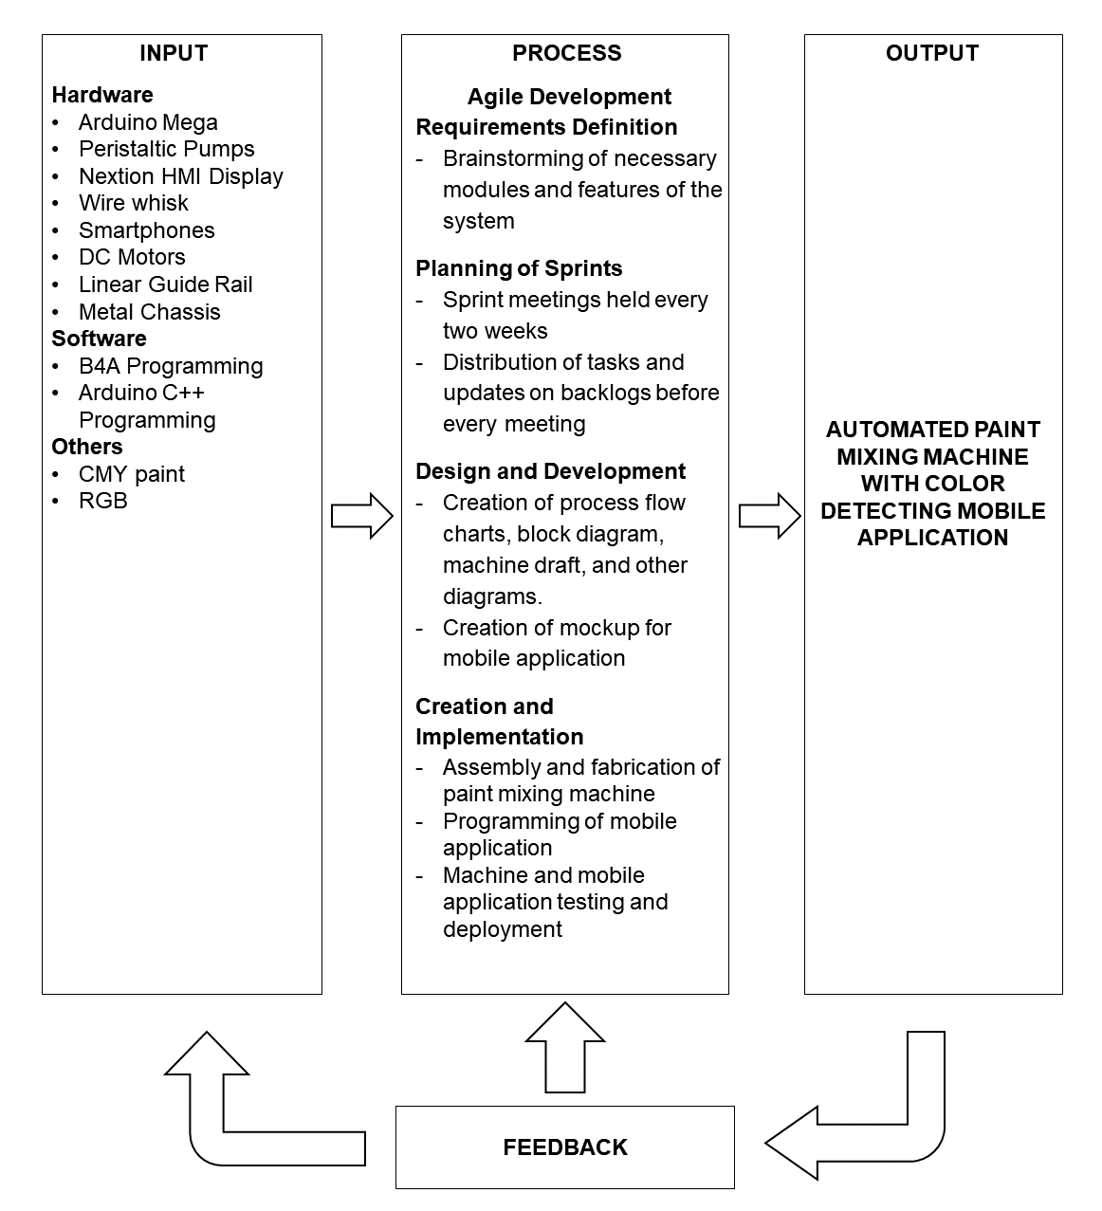

***Figure 2.1.1: Input-Process-Output (IPO) Model***

The process category contains the development method the researchers used in creating the system, which is the agile methodology. The agile methodology, which is a software development life cycle, is adapted to fit the project. Continuous iterations of development and testing for the duration of the project is the main principle in agile methodology (Srivastava et al., 2017). Under this, there are sub-methods that implement the principles of agile, and one of these is the scrum. The scrum methodology divides the development into sprints, where each sprint tackles a specific set of tasks and creates a usable product. The researchers proposed a two-week sprint cycle, and at the start of every sprint, the tasks were distributed and finished tasks were reported.

The proponents hypothesized that the system is capable of producing the output paint color that is perceivably similar to the actual input color based on the users’ evaluation. It is also hypothesized that the evaluation based on the ISO 25010 standard characteristics between the two types of respondents bear no statistical difference between their mean. It is assumed that the mean scores between the respondents are similar, indicating a unified evaluation of the machine.

* 1. **Data Gathering**

In order to acquire data to answer the problem statement, the researchers performed experimentations to test the system under various conditions as well as surveyed users using a questionnaire.

The experimentation included the testing of both the mobile application and the paint mixing machine. For the mobile application, sets of images were captured using different camera resolutions, particularly, 13 MP, 19 MP, and 64 MP Android cameras. The images were then processed by the application, and five different pixel points on the images were selected. The acquired CMY values for these points were recorded and compared to the actual CMY values of the pixels using the percent accuracy formula. This comparison allowed the researchers to gauge the accuracy of the mobile application in detecting the color of the pixel on the image. For the paint mixing machine, various color values were sent to the machine via Bluetooth to be processed, and the resulting output paint is then compared against the actual color values.

The survey was conducted both virtually and physically due to the current constraints. The respondents were generally divided into two groups, ordinary users of paint products, and the technical specialists who have knowledge in technology. The questionnaire used in gathering the data consists of characteristics based on the ISO 25010 standard, and a perceived color comparison question. The questions are in the form of Likert scale, and the data was statistically treated using the Welch’s T-test to determine statistical significance.

* 1. **Software Application**

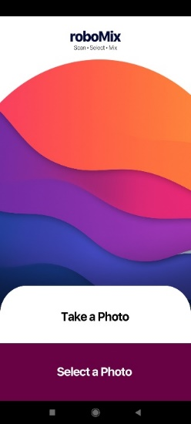 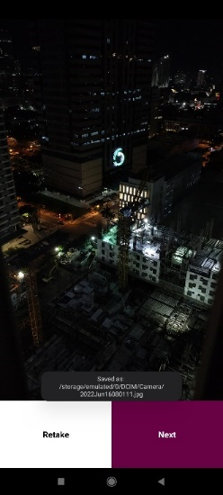 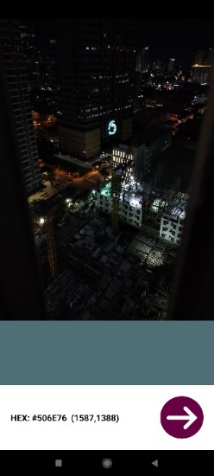 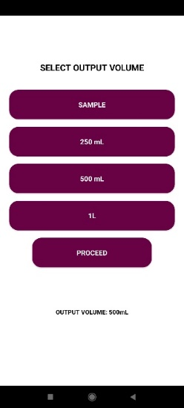

(a) (b) (c) (d)

***Figure 2.3.1. Mobile Application User Interface***

Figure 2.3.1 shows the major user interfaces in the mobile application. First, the user is given a choice between taking a live photo that will open the camera, or select a photo from their gallery (Figure 2.3.1.a). If the user opts to take a live photo, the camera application will open up and the user is able to capture an image. Once an image has been captured, the user can then proceed to the next step or retake an image (Figure 2.3.1.b). After selecting an image, either through live camera or the gallery, the user will then proceed to the pixel selection stage, where they can select a point in the image. The point is a pixel on the image, and the hex color value, as well as the coordinates of the pixel, is then displayed (Figure 2.3.1.c). Once satisfied with the color, the user then proceeds to the selecting the amount of paint to be dispensed (Figure 2.3.1.d). After the user proceeds, the information is sent to the Arduino Mega in the machine via Bluetooth connection.

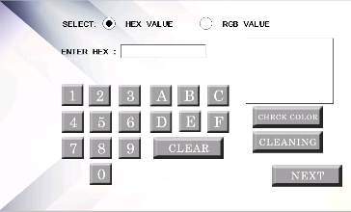 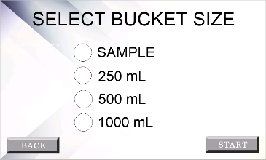

(a) (b)

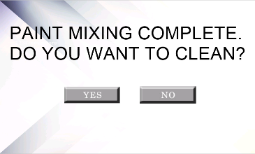 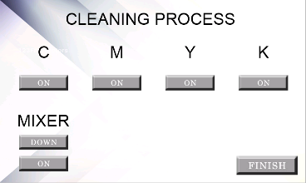

(c) (d)

***Figure 2.3.2. Nextion LCD User Interface***

The figure above displays the major interfaces for the Nextion touchscreen LCD. The device allows the user to manually input their desired color. The user is allowed to input either hex value or the RGB values using a custom virtual keypad (Figure 2.3.2.a). They are also allowed to go directly into cleaning mode. Similar to the mobile application, the user has a selection of output paint sizes to choose from (Figure 2.3.2.b). After the machine has completed the mixing process, the user is prompted whether they desire to undergo the cleaning process (Figure 2.3.2.c). It is important to note that the user should proceed with the cleaning process on a regular basis to avoid the drying of the paint inside the tubes. The cleaning process involves the manual activation of the pumps and the mixer, assuming that the input paint buckets are replaced with water for cleaning (Figure 2.3.2.d).

**2.4 Hardware Components**

The figure below shows the CAD design of the machine. The largest dimensions are 24 inches by 24 inches by 30 inches.

 

(a) (b)

 

(c) (d)

***Figure 2.4.1. Computer Aided Draft Design of the Prototype***

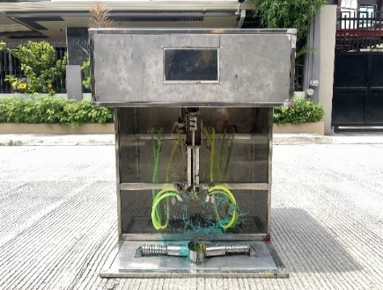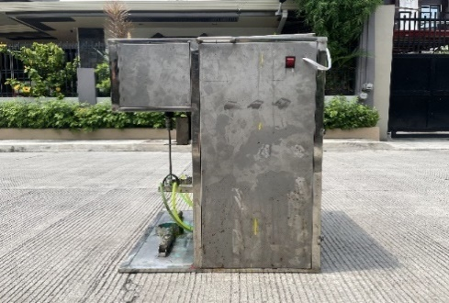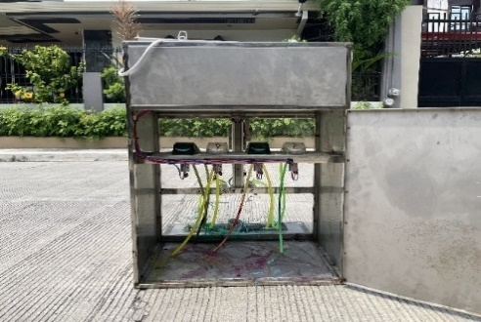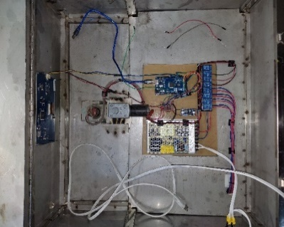

(a) (b) (c) (d)

***Figure 2.4.2. Actual Machine Prototype***

Shown in Figure 2.4.2 is the actual machine prototype. The machine is made from stainless steel to prevent corrosion. The front has a transparent plastic shielding, making it possible to view the pumps and the paint buckets. The level hose connects the input paint buckets to the pumps and out into the mixing container. The side of the machine has a rocker switch that enables powering the machine on and off (Figure 2.4.2.b). The back side has a compartment that holds the input CMY paint buckets, as well as the peristaltic pumps. The top compartment of the machine holds the microcontroller and other electronic components that enables and directs the machine (Figure 2.4.2.d). The major components of the machine include the Arduino Mega, Nextion LCD, power supply, relays, and DC motors.

**2.5 Machine Diagrams**

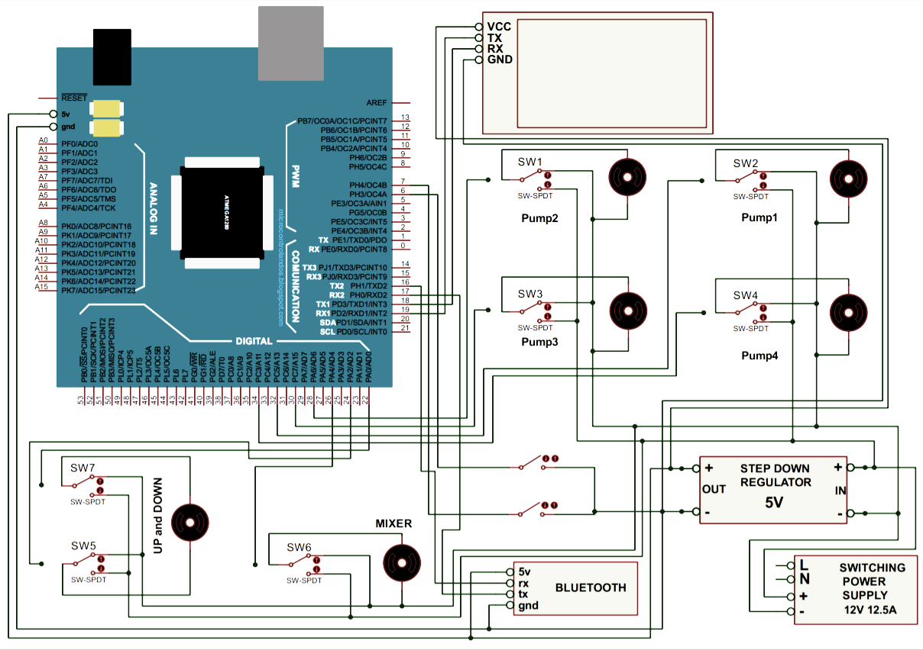

***Figure 2.5.1. Schematic Diagram of the Arduino MEGA to the Other Components***

The figure above presents the machine’s schematic diagram. The 12V power supply is connected to a step-down regulator that transforms the 12V input down to 5V. This 5V is used to directly power the Arduino Mega, which is the microcontroller of the circuit, the LCD, and the Bluetooth module. This is due to the maximum voltage limitation these components can handle, which is 5V. On the other hand, the peristaltic pumps and the DC motors are directly connected to the power supply via relay switches, which receive 12V directly in order to sustain their rotation. From there on, the Arduino Mega uses a 5V supply to trigger the relay switches, turning them on or off depending on its calculations and logic.

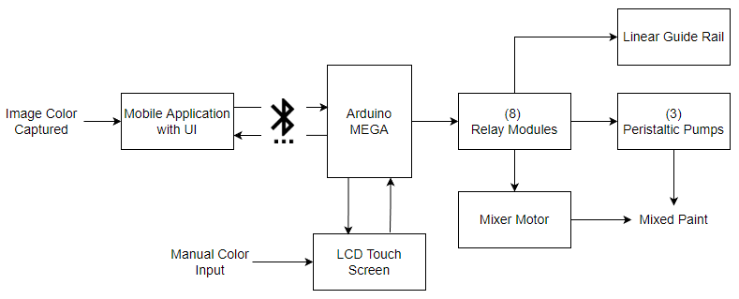

***Figure 2.5.2. Block Diagram of the System***

Figure 2.5.2 above is the block diagram of the machine. Based on the figure, there are two ways to input data into the machine, one via the mobile application, and another one via manual input on the touchscreen LCD. From the mobile application, data is sent via Bluetooth to the Arduino Mega, and the microcontroller is responsible for triggering the relay modules, which in turn activates or deactivates the corresponding component connected to it, which are the three peristaltic pumps connected to the input paint supply, the linear guide rail responsible for the upwards and downwards motion of the mixer, and the actual mixer motor responsible for the rotation of the whisk. After the process, a mixed paint is produced as an output of all the calculations made.

**3. RESULTS AND DISCUSSION**

**3.1 Perceived Accuracy**

***Table 3.1.1. Evaluation of Perceived Accuracy by the Respondents***



In Table 3.1.1, the Ordinary Users (OU) and the Technical Specialists (TS) were tasked to compare two colors, the actual input color and the output paint color of the system. The respondents were not given the color values, and instead used their perception to rate the similarity of the two using a Likert scale. The colors compared were chosen at random. The ordinary users gave average scores of 4.51, 4.46, 3.95, 3.71, and 3.49 for each sample, respectively. Meanwhile, the technical specialists conferred average scores of 4.33, 4.00, 3.67, 3.50, and 3.33 for each sample, respectively. The overall scores were interpreted, ranging from a slightly similar interpretation to a slightly dissimilar interpretation. Particularly, the last two colors comparison items scored a slightly dissimilar interpretation, the third item acquired a neutral similarity, and the first two items gathered a slightly similar interpretation result.

Based on their overall scores, the ordinary users score was interpreted to be having a slightly similar perception, while the technical specialists score was interpreted to be having a neutral similarity based on all samples. The data from this survey was then subjected to a Welch’s T-test, obtaining a t-value of 0.9103. The degrees of freedom (df) of the sample is six, and the critical value is 2.447. Because the t-value is less than the critical value, the researchers fail to reject the null hypothesis. This indicates that there is a general agreement between the two groups of respondents on the perceived similarity of the colors.

**3.2 Color Detection Accuracy**

***Table 3.2.1. Mobile Application Color Detection Accuracy***



In Table 3.2.1, two images were taken at similar settings, each using a different camera resolution. Five different pixel points on the image were selected at random, and the detected color values were recorded. These values were later compared to their actual color values to determine the accuracy. The 13 MP resolution acquired an average accuracy of 99.19% and 99.22% for each of the images. The 19 MP resolution obtained an average accuracy of 99.45% and 99.35% for each of the images. And lastly, the 64 MP resolution received an average accuracy of 99.90% and 99.79% for each of the images. Overall, all average accuracies were above 99% when compared to the actual color values.

**3.3 Scanned Color vs Output Paint Color**

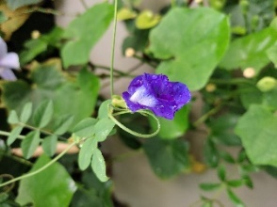 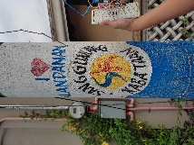

(a) (b)

***Figure 3.3.1. Images Used for Comparison***

The images above were captured through the mobile application using a 13 MP camera resolution with similar lighting conditions. These are used for the comparison between the color detected and the output paint color.

***Table 3.3.1. Comparison Between Color Detection And Output Paint Color for Figure 3.3.1.a***



***Table 3.3.2. Comparison Between Color Detection And Output Paint Color for Figure 3.3.1.b***



The two tables above summarize the results of the comparison between the scanned color and the output paint color of the system. For each of the figures in Figure 8, five pixels were randomly selected on the image. The coordinates of these pixels were recorded, along with the color values detected. The color values were sent to the machine to undergo the mixing process to create the colored paint. Once the mixing process is completed, the paint is then applied to a white paper, and then dried. After which, the color values between the scanned color and output color were then compared. The overall accuracy obtained were 87.11% for Figure 8.a, and 87.40% for Figure 8.b. The lowest accuracies were 81.31% and 80.13%, respectively. The accuracy results were above 85%, and can be interpreted as a satisfactory outcome.

**3.4 ISO 25010**

***Table 3.4.1. Evaluation of Respondents Using the ISO 25010 Standard***



The table above summarizes the results of the survey from two respondents, ordinary users and technical specialists. The ordinary users that participated in the study gave a general mean of 3.38 for all criteria, which is interpreted as a generally agreeing score. Similarly, the technical specialists also gave a generally agreeing score of 3.29. The t-value was then calculated based on the scores for each criterion, with functional suitability gaining 1.0274, performance efficiency with 0.9031, usability obtaining 1.0267, reliability gathered a t-value of 1.2401, and portability with 0.5190. The df was also calculated, and the critical value for each criterion was obtained in the t-distribution table. Comparing the t-value and the critical value, all criteria indicated the failure to reject the null hypothesis. There is a unified agreement between the respondents on their evaluation of the system based on the ISO 25010 standard.

# 4. SUMMARY, CONCLUSION, AND RECOMMENDATIONS

**4.1 Conclusion**

To generalize the whole study, it can be concluded that the machine is able to produce pigmented paint colors using CMY paint colors based on the input from the mobile application.

The use of agile methodology helps a lot in the development of the machine and the study. The proponents were able to determine the requirements and apply the design and concepts needed in developing the project. During the implementation, the user's feedback contributes a great factor in identifying the problems, thus allowing the proponents to improve the project by responding to changes in the requirements.

The perceived level of accuracy by ordinary users based on their evaluation of the 5 samples indicates that they perceived the output paint color as similar and neutral similarity for technical specialist. Therefore, the output paint color of the machine ranges from neutral to slightly similar in terms of perceived color.

The accuracy level of the scanned color compared to the actual color of the pixel based on 13 MP, 19 MP and 64 MP camera resolutions all received nearly identical levels. Therefore, the difference in camera resolution has a minute effect on the accuracy of the scanning accuracy of the mobile application.

The proponents decided to use the 13 MP to compare the images' scanned color and their output paint color received an average accuracy of 87.11% and 87.40, respectively. Therefore, the results indicate that the output paint colors are slightly similar, and by extension, satisfactory.

The respondents composed of ordinary users and technical specialist evaluated the machine and mobile application using the ISO 25010. The results of the survey indicate that the machine and mobile application have an interpreted score of generally agreeing based on the different characteristics of functional suitability, performance efficiency, usability, and reliability. The portability characteristic ranged from generally agreeing to generally disagreeing interpreted score. Therefore, both types of respondents arrive at a unified agreement of each characteristic.

**4.2 Recommendation**

Based on the data gathered, the proponents recommend the following for the betterment of future studies:

• Implement automatic switching between paint and water buckets. To achieve automated switching, the proponents recommend either using conveyor belts to move the buckets automatically or linear guides to move the tubes between paint and water buckets.

• Integrate an ultrasonic sensor for each paint bucket to monitor the paint levels. This will allow the customers and employees to monitor the paint levels.

• Add additional features for the mobile application such as integrating color palette and history of colors used. This will allow the user to expand their choices of colors by navigating the mobile application.

• Display previews of the images present on the user's phone storage when selecting an image to upload to the mobile application.

• Integrate white and black paint colors in the mixing process to enhance the accuracy of the product.

**5. REFERENCES**

1. BenQ Color Technology Lab. (2019, August 21). What is Color Gamut. Retrieved from BenQ: https://www.benq.com/en-ap/knowledge-center/knowledge/color-gamut-monitor.html

2. Boyat, A. K., & Joshi, B. K. (2015, April). A Review Paper: Noise Models in Digital Image Processing. Retrieved from Arxiv: https://arxiv.org/ftp/arxiv/papers/1505/1505.03489.pdf

3. Brindha, S., Kishorniya, P., Manickam, R., Chakkaravarthy, K. N., & Poomani, C. (2018). Automated Color Mixing Machine Using Arduino. International Journal of Engineering Research & Technology (IJERT), 6(04), 4. Retrieved from https://www.ijert.org/research/automated-color-mixing-machine-using-arduino-IJERTCONV6IS04081.pdf

4. da Silva, E. A., & Mendonca, G. V. (2007, September 2). Digital Image Processing. Retrieved from ScienceDirect: https://www.sciencedirect.com/science/article/pii/B9780121709600500645

5. Decker, K. (2017). The fundamentals of understanding color theory. Retrieved from 99designs: https://99designs.com/blog/tips/the-7-step-guide-to-understanding-color-theory/

6. George, G., Oommen, R. M., Shelly, S., Philipose, S. S., & Varghese, A. M. (2018, November 29). A survey on various median filtering techniques for removal of impulse noise from digital image. Retrieved from IEEE Xplore: https://ieeexplore.ieee.org/abstract/document/8544273

7. Hiltner, J. (2017, September). Vision Spectra. Retrieved from Embedded Vision Finds a Role in IOT: https://www.photonics.com/Articles/Embedded_Vision_Finds_a_Role_in_the_IIoT/a62511

8. Hussin, R., Juhari, M. R., Kang, N. W., Ismail, R. C., & Kamarudin, A. (2012, August 25). Digital Image Processing Techniques for Object Detection From Complex Background Image. Retrieved from ScienceDirect: https://www.sciencedirect.com/science/article/pii/S1877705812025684

9. McGavin, D., Stukenborg, B., & Witkowski, M. (2005, February). Color figures in BJ: RGB versus CMYK. Retrieved from NCBI: https://www.ncbi.nlm.nih.gov/pmc/articles/PMC1305152/

10. Mouw, T. (2018, August 10). Additive vs. Subtractive Color Models. Retrieved from xrite: https://www.xrite.com/blog/additive-subtractive-color-models

11. Oza, H. (2017, March 28). The Importance Of Mobile Applications In Everyday Life! Retrieved from Hyperlink Infosystem: https://www.hyperlinkinfosystem.com/blog/the-importance-of-mobile-applications-in-everyday-life

12. Prakash, R. M., Saraswathy, G. P., Ramalakshmi, G., Mangaleswari, K. H., & Kaviya, T. (2018, February 1). Detection of leaf diseases and classification using digital image processing. Retrieved from IEEE Xplore: https://ieeexplore.ieee.org/abstract/document/8275915

13. Scott, D. (2019, April 23). Subtractive and Additive Color – Different Systems for How We See Color. Retrieved from Draw Paint Academy: https://drawpaintacademy.com/subtractive-additive-color/

14. Singh, Y. (2019, September 3). The Paints and Coatings Industry in the Philippines. Retrieved from Coatings World: https://www.coatingsworld.com/issues/2019-09-01/view_india_asia_pacific_reports/the-paints-and-coatings-industry-in-the-philippines/

15. Stark, A. (2019, January 23). Construction Industry Is the Major Consumer of Paints and Coatings. Retrieved from Process WorldWide: https://www.process-worldwide.com/construction-industry-is-the-major-consumer-of-paints-and-coatings-a-792899/

16. Yabuki, N., Nishimura, N., & Fukuda, T. (2018, May 19). Automatic Object Detection from Digital Images by Deep Learning with Transfer Learning. Retrieved from Springer Link: https://link.springer.com/chapter/10.1007/978-3-319-91635-4_1

17. Zhuang, X., & Zhang, T. (2019, January 10). Detection of sick broilers by digital image processing and deep learning. Retrieved from ScienceDirect: https://www.sciencedirect.com/science/article/abs/pii/S1537511018307785

**ACKNOWLEDGEMENTS**

The proponents would like to express their deepest gratitude to their research advisers, ***Engr. Julius S. Cansino*** and ***Dr. Arvin R. De La Cruz*** for giving the opportunity to conduct the study with proper guidance and support. We wouldn’t be able to achieve such great work without their pieces of advice and suggestions about certain matters regarding its progress.

The proponents would also like to thank the ***Dalandanan Officials*** and their community for their assistance and cooperation during the prototype testing.

The proponents would also like to thank the ***family of Mr. Dizor*** for allowing us to conduct our experimentation in their residence at Dalandanan, Valenzuela City.

The proponents would also like to extend their gratitude to their ***families and friends*** for their unending love, support, and assistance.

Lastly, to ***almighty God*** for providing the proponents the wisdom, courage, and strength during the study.

**APPENDICES**

**Appendix 1: Design of the Automated Paint Mixing Machine with Color Detecting Mobile Application**

** **



*Initial proposed computer aided draft of the machine.*

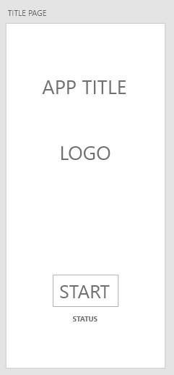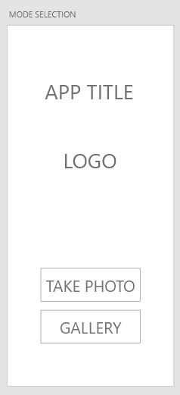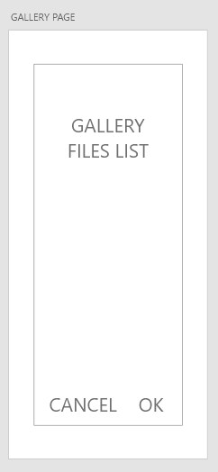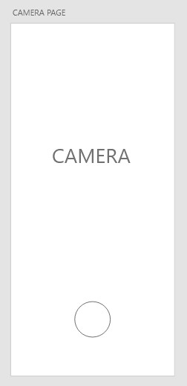

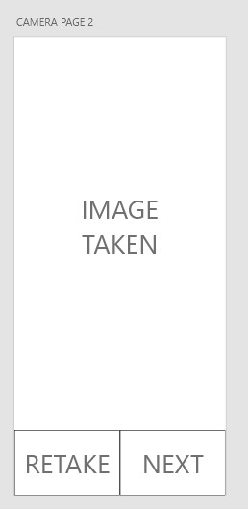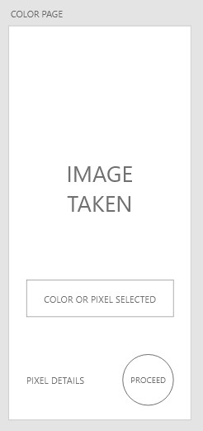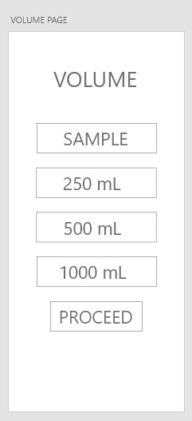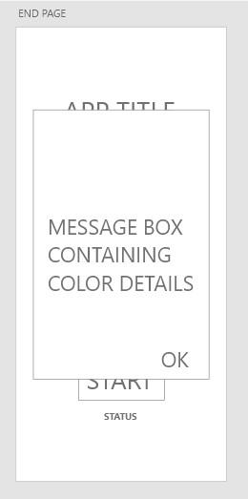

*Mockup of Mobile Application User Interface*

**Appendix 2: Actual Prototype and User Interface of the Automated Paint Mixing Machine with Color Detecting Mobile Application**

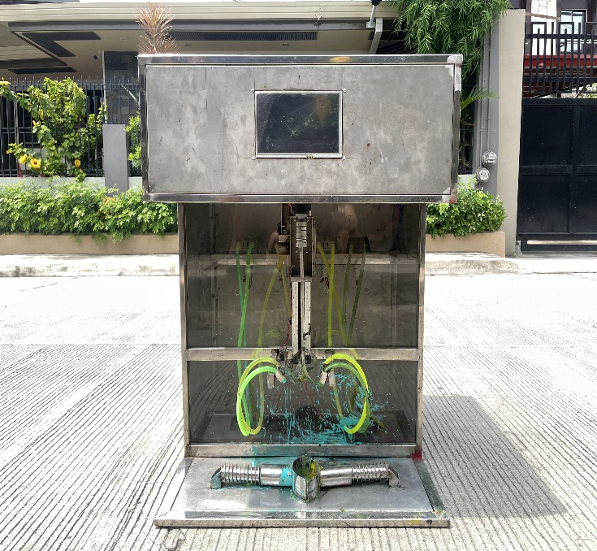 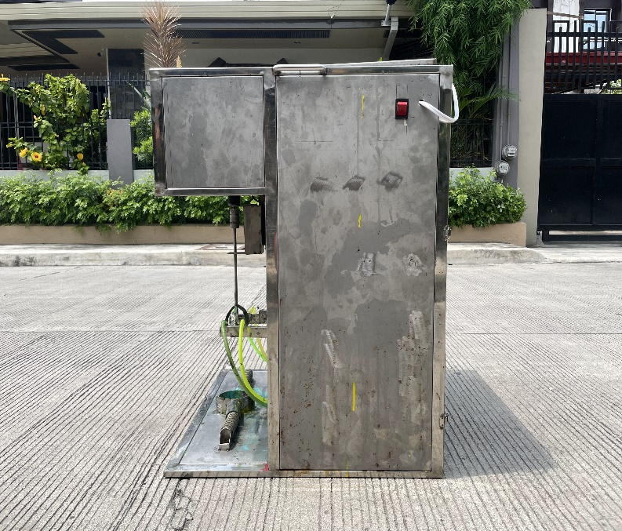

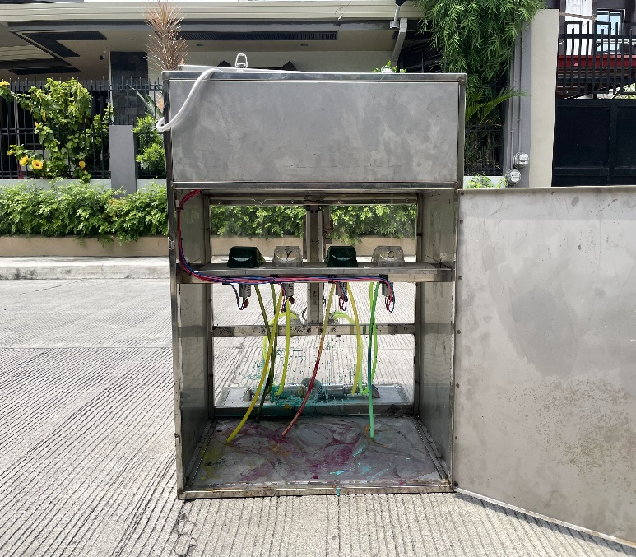 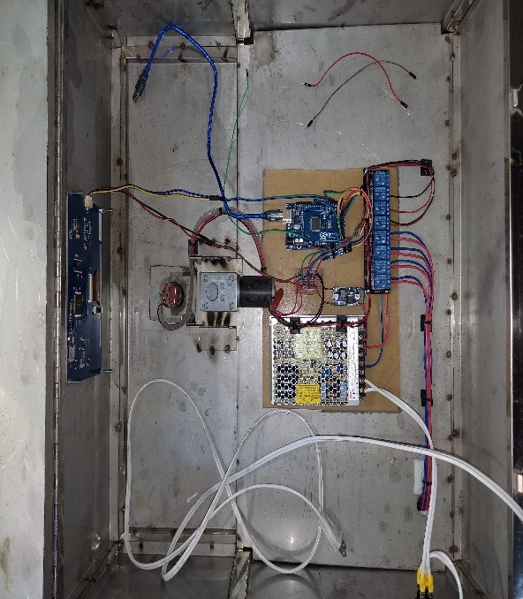

*Actual Internal and External Images of the Machine*

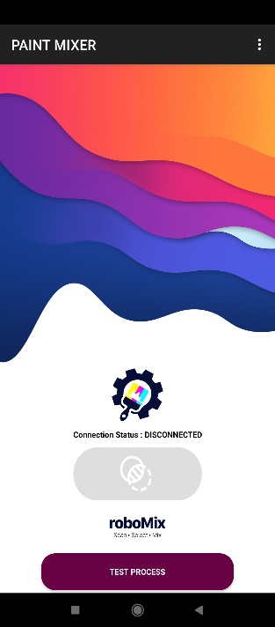 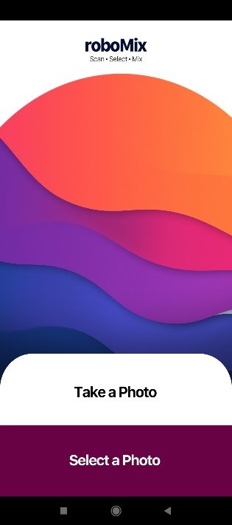 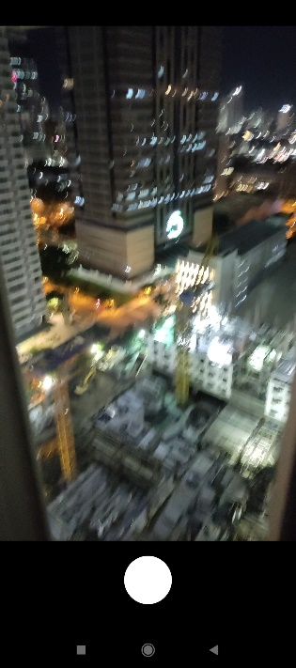 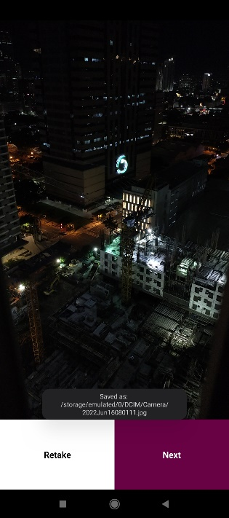

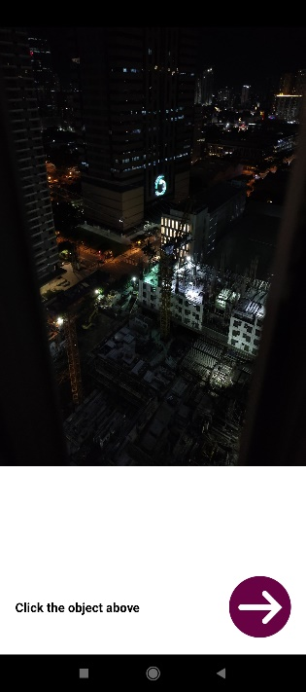 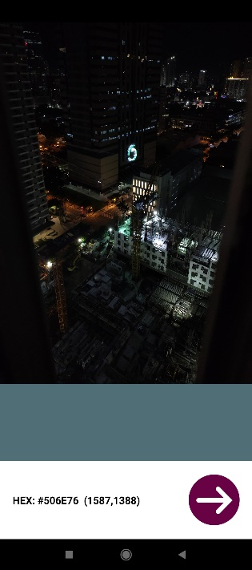 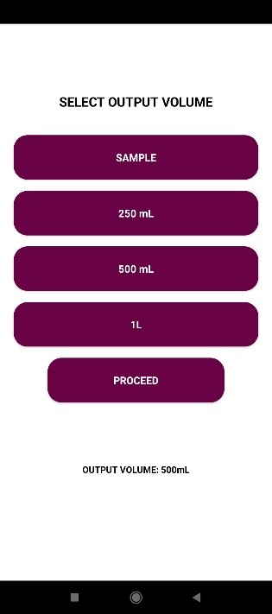 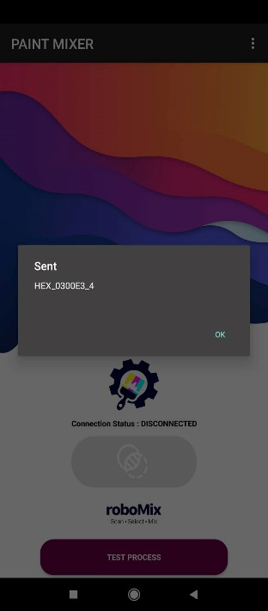

*Actual Screenshots of the Mobile Application User Interface*

**Appendix 3: Block and Schematic Diagram**



*Schematic Diagram of the Automated Paint Mixing Machine with Color Detecting Mobile Application*



*Block Diagram of the Automated Paint Mixing Machine with Color Detecting Mobile Application*

**Appendix 4: Flowchart**

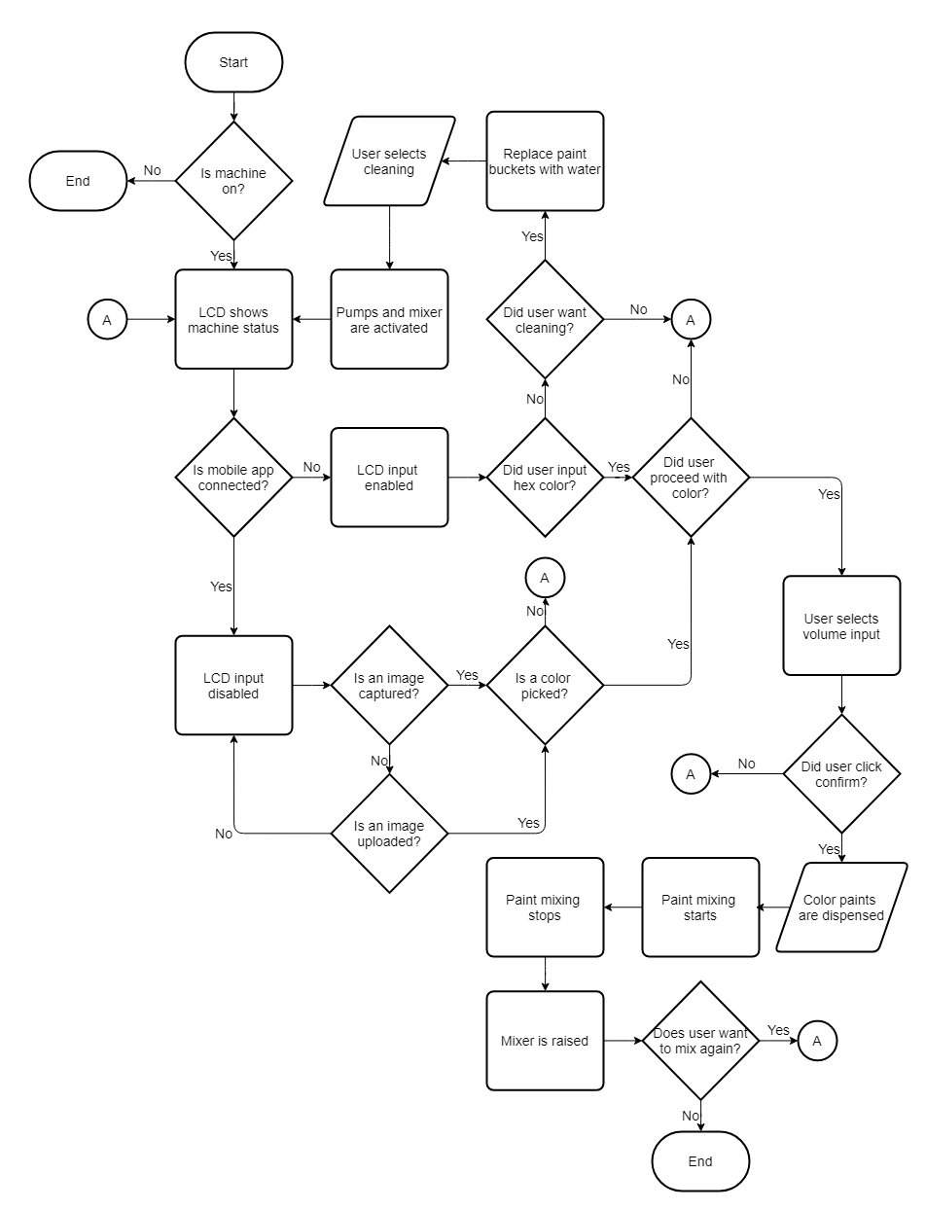

*Flowchart of the Automated Paint Mixing Machine with Color Detecting Mobile Application*

**Appendix 5: Kanban Board**

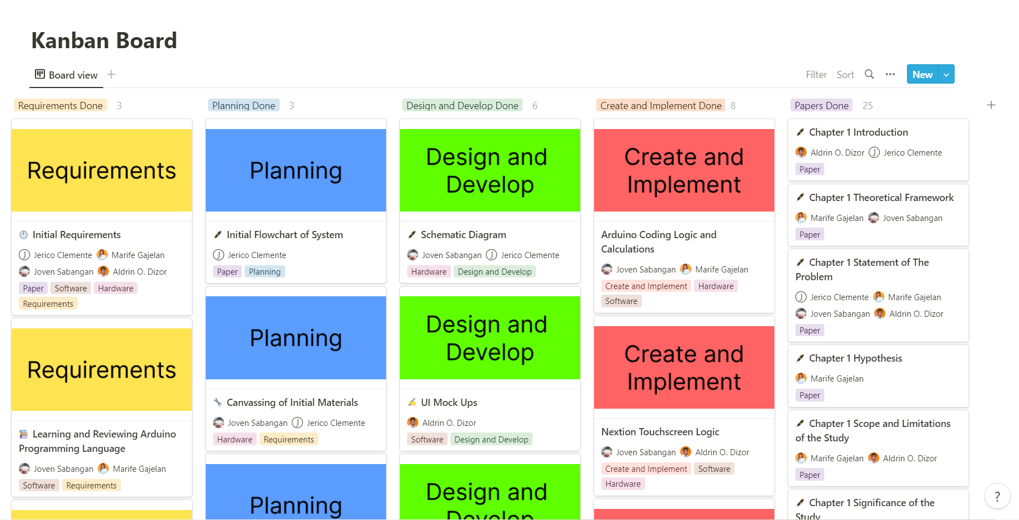

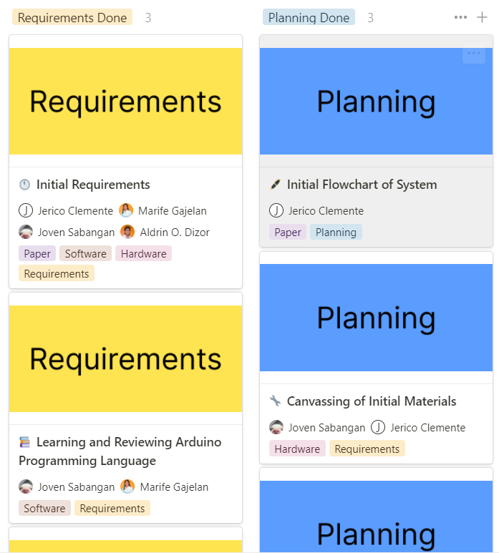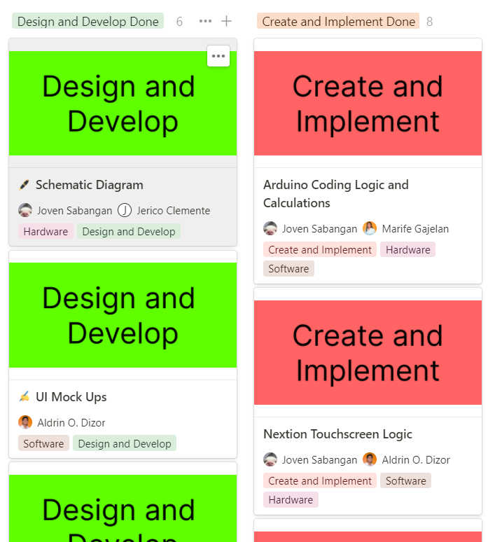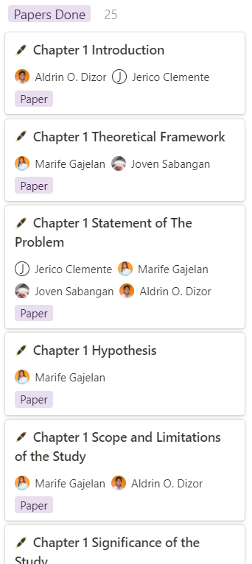

*Kanban Board Utilizing the Agile Methodology*

**Appendix 6: Ambient Light Sensor Using Light Dependent Resistor**

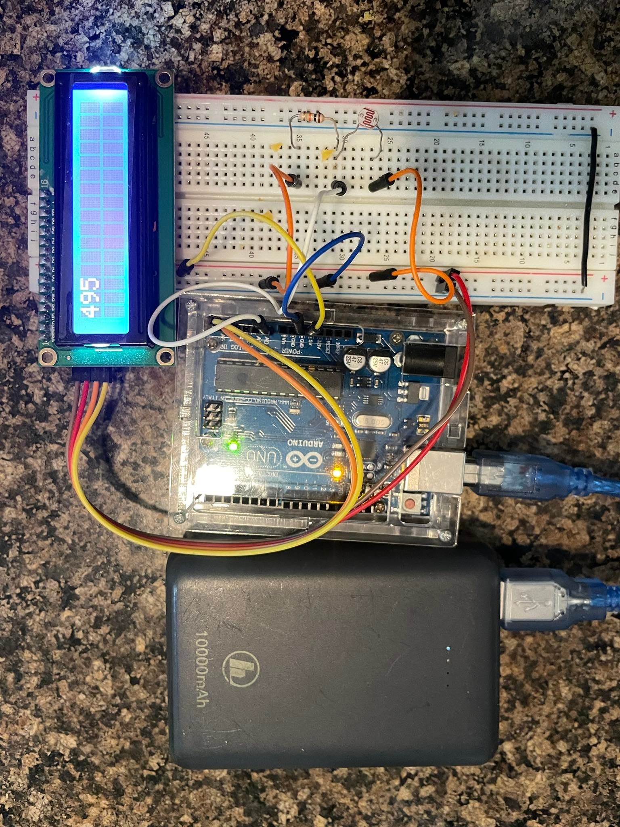

**Appendix 7: Arduino Source Code**

**Testing.ino**

#include <Nextion.h>

Nextion myNextion(Serial1, 9600); //create a Nextion object named myNextion using the nextion serial port @ 9600bps

#define Pump1 32

#define Pump2 28

#define Pump3 30

#define Pump4 34

#define mtrMixer_Up 24

#define mtrMixer_Dw 22

#define mtrMixer 26

#define lmtMixer_Up 6

#define lmtMixer_Dw 7

String Header, hex, strR, strG, strB, strMax_mL;

int R, G, B;

int Mixer_FL = 0;

float Rx=0, Gx=0, Bx=0;

float C=0, M=0, Y=0, K=0;

float Percent_T = 0, Percent_C=0, Percent_M=0, Percent_Y=0, Percent_K=0;

float Max_mL = 100, C_mL = 0, M_mL = 0, Y_mL = 0, K_mL = 0;

long mL_Delay = 7, C_Delay = 0, M_Delay = 0, Y_Delay = 0, K_Delay = 0;

long Temp_K = 0, Temp = 0;

int CTR = 0, Add_Delay = 0;

// ***** FOR NEXTION VALUE *****

long tempR, tempG, tempB;

long Red, Green, Blue;

long NextionVal;

// ****************************

void setup() {

// put your setup code here, to run once:

Serial.begin(9600); //Serial1.begin(9600);

Serial2.begin(9600); //Serial1.begin(9600);

myNextion.init();

delay(1000);

pinMode(Pump1, OUTPUT); digitalWrite(Pump1, HIGH);

pinMode(Pump2, OUTPUT); digitalWrite(Pump2, HIGH);

pinMode(Pump3, OUTPUT); digitalWrite(Pump3, HIGH);

pinMode(Pump4, OUTPUT); digitalWrite(Pump4, HIGH);

pinMode(mtrMixer_Up, OUTPUT); digitalWrite(mtrMixer_Up, HIGH);

pinMode(mtrMixer_Dw, OUTPUT); digitalWrite(mtrMixer_Dw, HIGH);

pinMode(mtrMixer, OUTPUT); digitalWrite(mtrMixer, HIGH);

pinMode(lmtMixer_Up, INPUT_PULLUP);

pinMode(lmtMixer_Up, INPUT_PULLUP);

Serial.println("INITIALIZING, PLEASE WAIT...");

// Mixer_Up();

Serial.println("READY");

delay(1000);

// myNextion.setComponentText("lblInitialize", "DONE");

// Test();

}

void Test(){

while(1){

if(Serial.available()){

switch(Serial.read()){

case '1': // ********** PUMP 1 ON/OFF **********

digitalWrite(Pump1, !digitalRead(Pump1));

break;

case '2': // ********** PUMP 2 ON/OFF **********

digitalWrite(Pump2, !digitalRead(Pump2));

break;

case '3': // ********** PUMP 3 ON/OFF **********

digitalWrite(Pump3, !digitalRead(Pump3));

break;

case '4': // ********** PUMP 4 ON/OFF **********

digitalWrite(Pump4, !digitalRead(Pump4));

break;

case '5': // ********** MIXER ON/OFF **********

digitalWrite(mtrMixer, !digitalRead(mtrMixer));

break;

case '6': // ********** MIXER UP ON/OFF **********

// digitalWrite(mtrMixer_Up, !digitalRead(mtrMixer_Up));

Mixer_Up();

break;

case '7': // ********** MIXER DOWN ON/OFF **********

// digitalWrite(mtrMixer_Dw, !digitalRead(mtrMixer_Dw));

Mixer_Down();

break;

case '8': // ********** SENSORS STATUS **********

Serial.print(digitalRead(lmtMixer_Up)); Serial.print("_");

Serial.print(digitalRead(lmtMixer_Dw)); Serial.println("");

}

}

}

}

void loop() {

// put your main code here, to run repeatedly:

String message = myNextion.listen();

if(message != ""){ // CHECKING IF THERES DATA COMING FROM NEXTION

if(message == "START"){

Dispensing_Cyan(C_Delay);

Dispensing_Magenta(M_Delay);

Dispensing_Yellow(Y_Delay);

Dispensing_Black(Temp_K);

Mixer_Down();

Mixing_Process(10); delay(2000); Mixing_Process(10);

Mixer_Up();

Serial.println("********** PROCESS COMPLETE! **********");

myNextion.setComponentText("lblStatus", "DONE");

}

else if(message == "CANCEL"){

Max_mL = 100;

mL_Delay = 12;

Serial.println("********** RESET PROCESS **********");

}

else if(message == "C_ON"){

Serial.println("C PUMP: ON");

digitalWrite(Pump1, LOW);

}

else if(message == "C_OFF"){

Serial.println("C PUMP: OFF");

digitalWrite(Pump1, HIGH);

}

else if(message == "M_ON"){

Serial.println("M PUMP: ON");

digitalWrite(Pump2, LOW);

}

else if(message == "M_OFF"){

Serial.println("M PUMP: OFF");

digitalWrite(Pump2, HIGH);

}

else if(message == "Y_ON"){

Serial.println("Y PUMP: ON");

digitalWrite(Pump3, LOW);

}

else if(message == "Y_OFF"){

Serial.println("Y PUMP: OFF");

digitalWrite(Pump3, HIGH);

}

else if(message == "K_ON"){

Serial.println("K PUMP: ON");

digitalWrite(Pump4, LOW);

}

else if(message == "K_OFF"){

Serial.println("K PUMP: OFF");

digitalWrite(Pump4, HIGH);

}

else if(message == "MIXER_DOWN"){

Serial.print("MIXER DOWN: ");

Mixer_Down();

Serial.println("DONE");

}

else if(message == "MIXER_UP"){

Serial.print("MIXER UP: ");

Mixer_Up();

Serial.println("DONE");

}

else if(message == "MIXER_ON"){

Serial.println("MIXER: ON");

digitalWrite(mtrMixer, LOW);

}

else if(message == "MIXER_OFF"){

Serial.println("MIXER: OFF");

digitalWrite(mtrMixer, HIGH);

}

else{

Serial.print("Message: "); Serial.println(message);

Header = message.substring(0, 3);

Serial.print("Header: ");Serial.println(Header);

if(Header == "HEX"){ // IF THE VALUE INPUT IS HEX

hex = message.substring(4, 10);

Serial.print("hex: ");Serial.println(hex);

GetRGBtoHEX(); // GET RGB IN HEX VALUE

ConvertHEXtoDEC(); // CONVERT HEX VALUE TO DECIMAL VALUE

Change_Range(); // The R,G,B values are divided by 255 to change the range from 0..255 to 0..1:

ConvertRGBtoCMYK(); // CONVERT RGB TO CMYK VALUE

ConvertCMYKtoPercent(); // CONVERT CMYK TO PERCENTAGE

}

else if(Header == "RGB"){ // IF THE VALUE INPUT IS RGB

strR = message.substring(4, 7); R = strR.toInt();

strG = message.substring(8, 11); G = strG.toInt();

strB = message.substring(12, 15); B = strB.toInt();

Serial.print("R: ");Serial.println(R);

Serial.print("G: ");Serial.println(G);

Serial.print("B: ");Serial.println(B);

Change_Range(); // The R,G,B values are divided by 255 to change the range from 0..255 to 0..1:

ConvertRGBtoCMYK(); // CONVERT RGB TO CMYK VALUE

ConvertCMYKtoPercent(); // CONVERT CMYK TO PERCENTAGE

}

else if(Header == "BUC"){ // IF THE VALUE INPUT IS RGB

strMax_mL = message.substring(4, 8); Max_mL = strMax_mL.toInt();

if(Max_mL == 100){ // FOR 100mL

mL_Delay = 12;

}

else if(Max_mL == 250){ // FOR 250mL

mL_Delay = 53;

}

else if(Max_mL == 500){ // FOR 500mL

mL_Delay = 106;

}

else{ // FOR 1000mL

mL_Delay = 202;

}

ConvertPercenttomL(); // CONVERT PERCENT TO mL

ConvertmLtoSec(); // CONVERT mL TO SEC

}

else if(Header == "CHA"){ // IF THE VALUE INPUT IS HEX

hex = message.substring(4, 10);

Serial.print("hex: ");Serial.println(hex);

GetRGBtoHEX(); // GET RGB IN HEX VALUE

ConvertHEXtoDEC(); // CONVERT HEX VALUE TO DECIMAL VALUE

RGBtoNextionVal();

// tempR = R;

// tempG = G;

// tempB = B;

//

// Red = ((long(tempR) >> long(3)) << long(11));

// Green = ((long(tempG) >> long(2)) << long(5));

// Blue = (long(tempB) >> long(3));

// NextionVal = Red + Green + Blue;

// Serial.println(NextionVal);

// myNextion.setComponentText("lblColorVal", "SAMPLE");

}

else if(Header == "CHE"){ // IF THE VALUE INPUT IS RGB

strR = message.substring(4, 7); R = strR.toInt();

strG = message.substring(8, 11); G = strG.toInt();

strB = message.substring(12, 15); B = strB.toInt();

RGBtoNextionVal();

}

}

message = "";

}

// ********** CONNECTION FROM ANDROID DEVICE **********

if(Serial2.available()){

String Data = Serial2.readString();

Serial.print("DATA : "); Serial.println(Data);

if(Data == "A"){

Serial.println("ANDROID CONNECTED");

myNextion.setComponentText("lblAndroid", "CONNECT");

}

else if(Data == "B"){

Serial.println("ANDROID NOT CONNECTED");

myNextion.setComponentText("lblProcess", "DISCONNECT");

}

else{

myNextion.setComponentText("lblProcess", "START");

hex = Data.substring(4, 10);

Serial.print("hex: ");Serial.println(hex);

GetRGBtoHEX(); // GET RGB IN HEX VALUE

ConvertHEXtoDEC(); // CONVERT HEX VALUE TO DECIMAL VALUE

Change_Range(); // The R,G,B values are divided by 255 to change the range from 0..255 to 0..1:

ConvertRGBtoCMYK(); // CONVERT RGB TO CMYK VALUE

ConvertCMYKtoPercent(); // CONVERT CMYK TO PERCENTAGE

String Temp_mL = Data.substring(11, 12);

Serial.print("Temp_mL : "); Serial.println(Temp_mL);

if(Temp_mL == "1"){

Max_mL = 100; mL_Delay = 12;

}

else if(Temp_mL == "2"){

Max_mL = 250; mL_Delay = 53;

}

else if(Temp_mL == "3"){

Max_mL = 500; mL_Delay = 106;

}

else{

Max_mL = 1000; mL_Delay = 202;

}

ConvertPercenttomL(); // CONVERT PERCENT TO mL

ConvertmLtoSec(); // CONVERT mL TO SEC

Dispensing_Cyan(C_Delay);

Dispensing_Magenta(M_Delay);

Dispensing_Yellow(Y_Delay);

Dispensing_Black(Temp_K);

Mixer_Down();

Mixing_Process(10); delay(2000); Mixing_Process(10);

Mixer_Up();

Serial.println("********** PROCESS COMPLETE! **********");

myNextion.setComponentText("lblStatus", "DONE");

}

}

}

void RGBtoNextionVal(){

tempR = R;

tempG = G;

tempB = B;

Red = ((long(tempR) >> long(3)) << long(11));

Green = ((long(tempG) >> long(2)) << long(5));

Blue = (long(tempB) >> long(3));

NextionVal = Red + Green + Blue;

Serial.println(NextionVal);

myNextion.setComponentText("lblNexColor", String(NextionVal));

}

**Functions.ino**

void GetRGBtoHEX(){

strR = hex.substring(0,2);

strG = hex.substring(2,4);

strB = hex.substring(4,6);

Serial.print("HEX-R: "); Serial.println(strR);

Serial.print("HEX-G: "); Serial.println(strG);

Serial.print("HEX-B: "); Serial.println(strB);

Serial.println();

}

unsigned int hexToDec(String hexString) {

unsigned int decValue = 0;

int nextInt;

for (int i = 0; i < hexString.length(); i++) {

nextInt = int(hexString.charAt(i));

if (nextInt >= 48 && nextInt <= 57) nextInt = map(nextInt, 48, 57, 0, 9);

if (nextInt >= 65 && nextInt <= 70) nextInt = map(nextInt, 65, 70, 10, 15);

if (nextInt >= 97 && nextInt <= 102) nextInt = map(nextInt, 97, 102, 10, 15);

nextInt = constrain(nextInt, 0, 15);

decValue = (decValue * 16) + nextInt;

}

return decValue;

}

void ConvertHEXtoDEC(){

R = hexToDec(strR);

G = hexToDec(strG);

B = hexToDec(strB);

Serial.print("R: "); Serial.println(R);

Serial.print("G: "); Serial.println(G);

Serial.print("B: "); Serial.println(B);

Serial.println();

}

void Change_Range(){

Rx = (float)R / 255;

Gx = (float)G / 255;

Bx = (float)B / 255;

Serial.print("Rx: "); Serial.println(Rx);

Serial.print("Gx: "); Serial.println(Gx);

Serial.print("Bx: "); Serial.println(Bx);

Serial.println();

}

void ConvertRGBtoCMYK(){

// K = 1 - max(max(Rx,Gx),Bx);

// C = (1-Rx-K) / (1-K);

// M = (1-Gx-K) / (1-K);

// Y = (1-Bx-K) / (1-K);

C = (1 - Rx);

M = (1 - Gx);

Y = (1 - Bx);

Serial.print("C: "); Serial.println(C);

Serial.print("M: "); Serial.println(M);

Serial.print("Y: "); Serial.println(Y);

Serial.print("K: "); Serial.println(K);

Serial.println();

}

void ConvertCMYKtoPercent(){

Percent_C = C * 100; Percent_C = round(Percent_C);

Percent_M = M * 100; Percent_M = round(Percent_M);

Percent_Y = Y * 100; Percent_Y = round(Percent_Y);

Percent_K = K * 100; Percent_K = round(Percent_K);

Serial.print("C%: "); Serial.println(Percent_C);

Serial.print("M%: "); Serial.println(Percent_M);

Serial.print("Y%: "); Serial.println(Percent_Y);

Serial.print("K%: "); Serial.println(Percent_K);

Serial.println();

}

void ConvertPercenttomL(){

// Max_mL = 1000;

Percent_T = Percent_C + Percent_M + Percent_Y + Percent_K;

C_mL = ((float)Percent_C / (float)Percent_T) * Max_mL;

M_mL = ((float)Percent_M / (float)Percent_T) * Max_mL;

Y_mL = ((float)Percent_Y / (float)Percent_T) * Max_mL;

K_mL = ((float)Percent_K / (float)Percent_T) * Max_mL;

C_mL = round(C_mL);

M_mL = round(M_mL);

Y_mL = round(Y_mL);

K_mL = round(K_mL);

Serial.print("Max_mL: "); Serial.println(Max_mL);

Serial.print("Percent_T: "); Serial.println(Percent_T);

Serial.print("C_mL: "); Serial.println(C_mL);

Serial.print("M_mL: "); Serial.println(M_mL);

Serial.print("Y_mL: "); Serial.println(Y_mL);

Serial.print("K_mL: "); Serial.println(K_mL);

Serial.println();

}

void ConvertmLtoSec(){

// mL_Delay = 30;

C_Delay = ((C_mL / Max_mL) * mL_Delay) * 1000;

M_Delay = ((M_mL / Max_mL) * mL_Delay) * 1000;

Y_Delay = ((Y_mL / Max_mL) * mL_Delay) * 1000;

K_Delay = ((K_mL / Max_mL) * mL_Delay) * 1000;

Temp_K = K_Delay / 10;

Temp = K_Delay - Temp_K;

if(C_Delay > 0){CTR++;}

if(M_Delay > 0){CTR++;}

if(Y_Delay > 0){CTR++;}

Add_Delay = Temp / CTR;

if(C_Delay > 0){C_Delay = C_Delay + Add_Delay;}

if(M_Delay > 0){M_Delay = M_Delay + Add_Delay;}

if(Y_Delay > 0){Y_Delay = Y_Delay + Add_Delay;}

Serial.print("mL_Delay: "); Serial.println(mL_Delay);

Serial.print("C_Delay: "); Serial.println(C_Delay);

Serial.print("M_Delay: "); Serial.println(M_Delay);

Serial.print("Y_Delay: "); Serial.println(Y_Delay);

Serial.print("K_Delay: "); Serial.println(K_Delay);

Serial.print("Temp_K_Delay: "); Serial.println(Temp_K);

Serial.print("Temp: "); Serial.println(Temp);

Serial.print("Add_Delay: "); Serial.println(Add_Delay);

Serial.print("CTR: "); Serial.println(CTR);

Serial.println();

}

void Dispensing_Cyan(long Sec){

Serial.print("Dispensing Cyan: ");

digitalWrite(Pump1, LOW);

for(long x = 1; x <= Sec; x++){

delay(1);

}

digitalWrite(Pump1, HIGH);

Serial.println("DONE");

delay(500);

}

void Dispensing_Magenta(long Sec){

Serial.print("Dispensing Magenta: ");

digitalWrite(Pump2, LOW);

for(long x = 1; x <= Sec; x++){

delay(1);

}

digitalWrite(Pump2, HIGH); delay(500);

Serial.println("DONE");

}

void Dispensing_Yellow(long Sec){

Serial.print("Dispensing Yellow: ");

digitalWrite(Pump3, LOW);

for(long x = 1; x <= Sec; x++){

delay(1);

}

digitalWrite(Pump3, HIGH); delay(500);

Serial.println("DONE");

}

void Dispensing_Black(long Sec){

Serial.print("Dispensing Black: ");

digitalWrite(Pump4, LOW);

for(long x = 1; x <= Sec; x++){

delay(1);

}

digitalWrite(Pump4, HIGH); delay(500);

Serial.println("DONE");

}

void Mixer_Up(){

if(digitalRead(lmtMixer_Up) == HIGH){

digitalWrite(mtrMixer_Up, LOW); delay(50);

while(digitalRead(lmtMixer_Up) == HIGH);

digitalWrite(mtrMixer_Up, HIGH); delay(50);

}

}

void Mixer_Down(){

if(digitalRead(lmtMixer_Dw) == HIGH){

digitalWrite(mtrMixer_Dw, LOW); delay(50);

while(digitalRead(lmtMixer_Dw) == HIGH);

digitalWrite(mtrMixer_Dw, HIGH); delay(50);

}

}

void Mixing_Process(int Sec){

Serial.print("MIXING: ");

digitalWrite(mtrMixer, LOW);

for(int x = 1; x <= Sec; x++){

delay(1000);

}

digitalWrite(mtrMixer, HIGH); delay(500);

Serial.println("DONE");

}

**Appendix 8: Mobile Application Source Code**

**Main.bas**

#Region Project Attributes

#ApplicationLabel:Paint Mixer

#VersionCode: 1

#VersionName:

'SupportedOrientations possible values: unspecified, landscape or portrait.

#SupportedOrientations: portrait

#CanInstallToExternalStorage: False

#End Region

#Region Activity Attributes

#FullScreen: True

#IncludeTitle: False

#End Region

Sub Process_Globals

'These global variables will be declared once when the application starts.

'These for

'Forvariables can be accessed from all modules.

#Region "Bluetooth Connection Declares"

Dim SerialCon As Serial

Dim BT_Admin As BluetoothAdmin

Dim AStreams As AsyncStreams

Dim BT_List As List

Dim MA_List As List

Dim timer1 As Timer

Dim BT_IsOn As Boolean : BT_IsOn = False

Dim SC_IsConnected As Boolean : SC_IsConnected = False

Dim isAskingForPairedList As Boolean : isAskingForPairedList = False

Dim rBuffer As String

#End Region

End Sub

Sub Globals

'These global variables will be redeclared each time the activity is created.

'These variables can only be accessed from this module.

Dim cBuffer() As Byte

Dim ComString As String

Dim btnSender As Button

Private btnStart As Button

Private lblConnectionStatus As Label

Private iv As ImageView

Private Button1 As Button

Private Connect As Button

End Sub

Sub Activity_Create(FirstTime As Boolean)

'Do not forget to load the layout file created with the visual designer. For example:

'Starter. Rp. CheckAndRequest (Starter. Rp. PERMISSION_WRITE_EXTERNAL_STORAGE)

Activity.LoadLayout("MainForm")

Activity.AddMenuItem("Manage Connections", "mnuConnections")

Starter. Rp. CheckAndRequest (Starter. Rp. PERMISSION_READ_EXTERNAL_STORAGE)

Wait For Activity_PermissionResult (Permission As String, Result As Boolean)

Starter.rp.CheckAndRequest(Starter.rp.PERMISSION_WRITE_EXTERNAL_STORAGE)

Wait For Activity_PermissionResult (Permission As String, Result As Boolean)

If BT_List.IsInitialized = False Then BT_List.Initialize

If MA_List.IsInitialized = False Then MA_List.Initialize

btnStart.Enabled = False

Button1.Visible = True

timer1.Initialize("Timer1", 1000)

timer1.Enabled = True

iv.Bitmap = LoadBitmap(File.DirAssets, "Red.bmp")

End Sub

Sub Timer1_Tick

If Starter.bluetooth_logic =1 Then

ComString = Starter.bluetooth_string : cBuffer = ComString.GetBytes("UTF8") : AStreams.Write(cBuffer)

Msgbox(Starter.bluetooth_string,"Sent")

Log("sent")

Starter.bluetooth_logic =0

Else

End If

End Sub

Sub Activity_Resume

If BT_Admin.IsInitialized = False Then

BT_Admin.Initialize("BT_Admin") : SerialCon.Initialize("SerialCon")

End If

End Sub

Sub Activity_Pause (UserClosed As Boolean)

End Sub

Sub Activity_KeyPress (KeyCode As Int) As Boolean

If KeyCode = KeyCodes.KEYCODE_BACK Then

If Msgbox2("Are you sure you want to close this program?","Confirmation.","Yes","","No", Null) = DialogResponse.POSITIVE Then

If SC_IsConnected = True Then

ComString = "B" : cBuffer = ComString.GetBytes("UTF8") : AStreams.Write(cBuffer)

AStreams.Close : SerialCon.Disconnect : SC_IsConnected = False

ToastMessageShow("Serial Communication Disconnected", False)

lblConnectionStatus.Text = "Connection Status : DISCONNECTED"

btnStart.Enabled = False

End If

Activity.Finish

Else

Return True

End If

End If

End Sub

Sub mnuConnections_Click

Dim OptionList As List

Dim OptionSel As Int

OptionList.Initialize2(Array As String("Connect Device","Disconnect Device"))

OptionSel = InputList(OptionList,"Manage Connection",-1)

Select Case OptionSel

Case 0

InitiateBTConnection

Case 1

DisconnectBTConnection

End Select

End Sub

#Region "Functions : Communications"

Sub InitiateBTConnection

If BT_Admin.IsEnabled = False Then

If Msgbox2("Enable Bluetooth?","Bluetooth Required","Yes","","No", Null) = DialogResponse.POSITIVE Then

isAskingForPairedList = True

BT_Admin.Enable

End If

Else

If SC_IsConnected = False Then

ProgressDialogShow("Connecting to Bluetooth ... Please wait.")

SerialCon.Connect("98:D3:B1:FD:76:51") 'convert the name to mac address

' If BT_List.Size > 0 Then

' Dim res As Int

' res = InputList(BT_List, "Choose Device", -1) 'show list with paired devices

' If res <> DialogResponse.CANCEL Then

' Try

' ProgressDialogShow("Connecting to " & BT_List.Get(res))

' SerialCon.Connect(MA_List.Get(res)) 'convert the name to mac address

' Catch

' Msgbox("Error Connecting To Selected Device.","Error")

' End Try

' End If

' Else

' BT_Admin.StartDiscovery

' End If

Else

Msgbox("You are already connected. Please disconnect from your current connection first.","Error")

End If

End If

End Sub

Sub DisconnectBTConnection

If SC_IsConnected = True Then

ComString = "B" : cBuffer = ComString.GetBytes("UTF8") : AStreams.Write(cBuffer)

AStreams.Close : SerialCon.Disconnect : SC_IsConnected = False

ToastMessageShow("Serial Communication Disconnected", False)

lblConnectionStatus.Text = "Connection Status : DISCONNECTED"

btnStart.Enabled = False

Else

Msgbox("You are not connected to the device.","Error")

End If

End Sub

Sub AStreams_NewData (Buffer() As Byte)

Try

Dim rByte As String

rByte = BytesToString(Buffer, 0, Buffer.Length, "UTF8")

rBuffer = rBuffer & rByte

If rBuffer.StartsWith("DATA_") And rBuffer.Length > 5 Then

If rBuffer.EndsWith("_OK") Then ' Get All ADC Value.

Try

Dim ADCRaw As String

ADCRaw = rBuffer.SubString2(5,rBuffer.IndexOf("_OK"))

Dim parsedSTR() As String = Regex.Split("_", ADCRaw)

If parsedSTR.Length = 1 Then

End If

rBuffer = ""

Catch

rBuffer = ""

End Try

Else If rBuffer.Length > 50 Then ' Reset Buffer.

rBuffer = ""

End If

Else If rBuffer.Length > 50 Then ' Reset Buffer.

rBuffer = ""

End If

Catch

Log(LastException)

rBuffer = ""

End Try

End Sub

Sub AStreams_Error

Msgbox("Data Connection Error. Please Check Bluetooth Connectivity","Fatal Error")

End Sub

Sub SerialCon_Connected (Success As Boolean)

ProgressDialogHide

If Success Then

ToastMessageShow("Connected successfully", False)

AStreams.Initialize(SerialCon.InputStream,SerialCon.OutputStream,"AStreams")

SC_IsConnected = True

lblConnectionStatus.Text = "Connection Status : CONNECTED"

btnStart.Enabled = True

ComString = "A" : cBuffer = ComString.GetBytes("UTF8") : AStreams.Write(cBuffer)

Else

SC_IsConnected = False

Msgbox(LastException.message, "Error connecting.")

End If

End Sub

#End Region

For

#Region "Bluetooth Events"

Sub BT_Admin_DiscoveryStarted

If BT_List.IsInitialized = False Then BT_List.Initialize

If MA_List.IsInitialized = False Then MA_List.Initialize

BT_List.Clear : MA_List.Clear

ProgressDialogShow("Scanning Devices..")

End Sub

Sub BT_Admin_DiscoveryFinished

ProgressDialogHide

' Dim res As Int

' res = InputList(BT_List, "Choose device", -1) 'show list with paired devices

' If res <> DialogResponse.CANCEL Then

Try

' SerialCon.Connect(MA_List.Get(res)) 'convert the name to mac address

ProgressDialogShow("Connecting to Bluetooth ... Please wait.")

SerialCon.Connect("98:D3:B1:FD:76:51") 'convert the name to mac address

Catch

Msgbox("Error Connecting To Selected Device.","Error")

End Try

' End If

End Sub

Sub BT_Admin_DeviceFound (Name As String, MacAddress As String)

ProgressDialogShow("Detected: " & Name & ":" & MacAddress)

BT_List.Add(Name) : MA_List.Add(MacAddress)

End Sub

Sub BT_Admin_StateChanged(NewState As Int, OldState As Int)

If NewState = BT_Admin.STATE_TURNING_ON Then

ProgressDialogShow("Turning On Bluetooth.")

Else If NewState = BT_Admin.STATE_ON Then

ProgressDialogHide

ToastMessageShow("Bluetooth Enabled",False)

If isAskingForPairedList = True Then

isAskingForPairedList = False

BT_Admin.StartDiscovery

End If

BT_IsOn = True

Else If NewState = BT_Admin.STATE_OFF Then

ToastMessageShow("Bluetooth Disabled",False)

BT_IsOn = False

End If

End Sub

#End Region

Sub btnStart_Click

Starter.bluetooth_logic = 0

StartActivity(HOME_CODE)

End Sub

Sub Button1_Click

Starter.bluetooth_logic = 0

StartActivity(HOME_CODE)

End Sub

Sub Connect_Click

Dim OptionList As List

Dim OptionSel As Int

OptionList.Initialize2(Array As String("Connect Device","Disconnect Device"))

OptionSel = InputList(OptionList,"Manage Connection",-1)

Select Case OptionSel

Case 0

InitiateBTConnection

Case 1

DisconnectBTConnection

End Select

End Sub

**Starter.bas**

#Region Service Attributes

#StartAtBoot: True

#ExcludeFromLibrary: True

#End Region

Sub Process_Globals

'These global variables will be declared once when the application starts.

'These variables can be accessed from all modules.

Public rp As RuntimePermissions

Public bmp As B4XBitmap

Public bluetooth_string As String

Public filename As String

Public bluetooth_logic As Int

bluetooth_logic = 0

Public hex_color As String

End Sub

Sub Service_Create

'This is the program entry point.

'This is a good place to load resources that are not specific to a single activity.

End Sub

Sub Service_Start (StartingIntent As Intent)

Service.StopAutomaticForeground 'Starter service can start in the foreground state in some edge cases.

End Sub

Sub Service_TaskRemoved

'This event will be raised when the user removes the app from the recent apps list.

End Sub

'Return true to allow the OS default exceptions handler to handle the uncaught exception.

Sub Application_Error (Error As Exception, StackTrace As String) As Boolean

Return True

End Sub

Sub Service_Destroy

End Sub

**HOME_CODE.bas**

#Region Activity Attributes

#FullScreen: True

#IncludeTitle: False

#End Region

Sub Process_Globals

'These global variables will be declared once when the application starts.

'These variables can be accessed from all modules.

Private timer1 As Timer

End Sub

Sub Globals

'These global variables will be redeclared each time the activity is created.

'These variables can only be accessed from this module.

Private btnlivephoto As Button

Private btncamroll As Button

End Sub

Sub Activity_Create(FirstTime As Boolean)

'Do not forget to load the layout file created with the visual designer. For example:

Activity.LoadLayout("HOME_PAGE")

'timer1.Initialize

timer1.Initialize("Timer1", 1000)

End Sub

Sub Timer1_Tick

'Handle tick events

timer1.Enabled = False

Dim fd As FileDialog

fd.FastScroll = True

fd.FilePath = File.Combine(File.DirRootExternal, "/DCIM/Camera/")

fd.FileFilter = ".jpg"

Dim myfile As String

fd.Show("Select receipt picture to associate this expense to.", "Okay", "Cancel", "", Null)

Starter.filename=fd.ChosenName ''will return the file name you select

If Starter.filename = "" Then

btncamroll.Enabled = True

btncamroll.Text = "Camera Roll"

Else

StartActivity(EDIT_CODE)

Activity.Finish

End If

End Sub

Sub Activity_Resume

End Sub

Sub Activity_Pause (UserClosed As Boolean)

End Sub

Sub btnlivephoto_Click

StartActivity(LIVE_CODE)

Activity.Finish

End Sub

Sub btncamroll_Click

btncamroll.Enabled = False

'btncamroll.Text = "Please Wait..."

timer1.Enabled = True

End Sub

**LIVE_CODE.bas**

#Region Activity Attributes

#FullScreen: True

#IncludeTitle: False

#End Region

Sub Process_Globals

'These global variables will be declared once when the application starts.

'These variables can be accessed from all modules.

Private frontCamera As Boolean = False

End Sub

Sub Globals

'These global variables will be redeclared each time the activity is created.

'These variables can only be accessed from this module.

Private Panel1 As Panel

Private camEx As CameraExClass

Private Panel2 As Panel

Private Retake As Button

Private Next1 As Button

Private btnlivephoto As Button

Private Panel3 As Panel

Private Button1 As Button

End Sub

Private Sub InitializeCamera

Starter.rp.CheckAndRequest(Starter.rp.PERMISSION_CAMERA)

Wait For Activity_PermissionResult (Permission As String, Result As Boolean)

If Result Then

camEx.Initialize(Panel2, frontCamera, Me, "Camera1")

frontCamera = camEx.Front

Else

ToastMessageShow("No permission!!!", True)

End If

End Sub

Sub Activity_Resume

InitializeCamera

End Sub

Sub Activity_Create(FirstTime As Boolean)

'Do not forget to load the layout file created with the visual designer. For example:

Activity.LoadLayout("LIVE_PAGE")

End Sub

Sub Activity_Pause (UserClosed As Boolean)

End Sub

Sub Camera1_Ready (Success As Boolean)

If Success Then

camEx.SetJpegQuality(100)

camEx.SetContinuousAutoFocus

camEx.CommitParameters

camEx.StartPreview

Log(camEx.GetPreviewSize)

Else

ToastMessageShow("Cannot open camera.", True)

End If

End Sub

Sub Camera1_PictureTaken (Data() As Byte)

DateTime.DateFormat="yyyyMMMddhhmmss"

Starter.filename = DateTime.Date(DateTime.now)&".jpg"

Dim dir As String = File.DirRootExternal & "/DCIM/Camera"

camEx.SavePictureToFile(Data, dir, Starter.filename)

ToastMessageShow("Saved as: " & CRLF & dir & "/" & Starter.filename, True)

'Dim x As B4XView = Panel2

'Starter.bmp = x.Snapshot

btnlivephoto.Visible = False

Retake.Visible = True

Next1.Visible = True

' Dim bd As BitmapDrawable

' bd.Initialize(LoadBitmap(File.DirInternal, "1.jpg").Rotate(90))

' bd.Gravity = Gravity.FILL

' Panel3.Background = bd

' Panel3.Visible = True

End Sub

Sub Panel2_Touch (Action As Int, X As Float, Y As Float)

' If Action = 1 Then

' Msgbox("XY",X & " " & Y)

' End If

End Sub

Sub btnlivephoto_Click

camEx.TakePicture

End Sub

Sub Retake_Click

Panel3.Visible = False

btnlivephoto.Visible = True

Retake.Visible = False

Next1.Visible = False

camEx.StartPreview 'restart preview

End Sub

Sub Next1_Click

StartActivity(EDIT_CODE)

Activity.Finish

End Sub

**CameraExClass.bas**

'Class module

'version 1.30

'See this page for the list of constants:

'http://developer.android.com/intl/fr/reference/android/hardware/Camera.Parameters.html

'Note that you should use the constant values instead of the names.

Sub Class_Globals

Private nativeCam As Object

Private cam As Camera

Private r As Reflector

Private target As Object

Private event As String

Public Front As Boolean

Type CameraInfoAndId (CameraInfo As Object, Id As Int)

Type CameraSize (Width As Int, Height As Int)

Private parameters As Object

End Sub

Public Sub Initialize (Panel2 As Panel, FrontCamera As Boolean, TargetModule As Object, EventName As String)

target = TargetModule

event = EventName

Front = FrontCamera

Dim id As Int

id = FindCamera(Front).id

If id = -1 Then

Front = Not(Front) 'try different camera

id = FindCamera(Front).id

If id = -1 Then

ToastMessageShow("No camera found.", True)

Return

End If

End If

cam.Initialize2(Panel2, "camera", id)

End Sub

Private Sub FindCamera (frontCamera As Boolean) As CameraInfoAndId

Dim ci As CameraInfoAndId

Dim cameraInfo As Object

Dim cameraValue As Int

Log("findCamera")

If frontCamera Then cameraValue = 1 Else cameraValue = 0

cameraInfo = r.CreateObject("android.hardware.Camera$CameraInfo")

Dim numberOfCameras As Int = r.RunStaticMethod("android.hardware.Camera", "getNumberOfCameras", Null, Null)

Log(r.target)

Log(numberOfCameras)

For i = 0 To numberOfCameras - 1

r.RunStaticMethod("android.hardware.Camera", "getCameraInfo", Array As Object(i, cameraInfo), _

Array As String("java.lang.int", "android.hardware.Camera$CameraInfo"))

r.target = cameraInfo

Log("facing: " & r.GetField("facing") & ", " & cameraValue)

If r.GetField("facing") = cameraValue Then

ci.cameraInfo = r.target

ci.Id = i

Return ci

End If

Next

ci.id = -1

Return ci

End Sub

Private Sub SetDisplayOrientation

r.target = r.GetActivity

r.target = r.RunMethod("getWindowManager")

r.target = r.RunMethod("getDefaultDisplay")

r.target = r.RunMethod("getRotation")

Dim previewResult, result, degrees As Int = r.target * 90

Dim ci As CameraInfoAndId = FindCamera(Front)

r.target = ci.CameraInfo

Dim orientation As Int = r.GetField("orientation")

If Front Then

previewResult = (orientation + degrees) Mod 360

result = previewResult

previewResult = (360 - previewResult) Mod 360

Else

previewResult = (orientation - degrees + 360) Mod 360

result = previewResult

Log(previewResult)

End If

r.target = nativeCam

r.RunMethod2("setDisplayOrientation", previewResult, "java.lang.int")

r.target = parameters

r.RunMethod2("setRotation", result, "java.lang.int")

CommitParameters

End Sub

Private Sub Camera_Ready (Success As Boolean)

If Success Then

r.target = cam

nativeCam = r.GetField("camera")

r.target = nativeCam

parameters = r.RunMethod("getParameters")

SetDisplayOrientation

Else

Log("success = false, " & LastException)

End If

CallSub2(target, event & "_ready", Success)

End Sub

'Uncomment this sub if you need to handle the Preview event

'Sub Camera_Preview (Data() As Byte)

' If SubExists(target, event & "_preview") Then

' CallSub2(target, event & "_preview", Data)

' End If

'End Sub

Public Sub TakePicture

cam.TakePicture

End Sub

Private Sub Camera_PictureTaken (Data() As Byte)

CallSub2(target, event & "_PictureTaken", Data)

End Sub

Public Sub StartPreview

cam.StartPreview

End Sub

Public Sub StopPreview

cam.StopPreview

End Sub

Public Sub Release

cam.Release

End Sub

'Saves the data received from PictureTaken event

Public Sub SavePictureToFile(Data() As Byte, Dir As String, FileName As String)

Dim out As OutputStream = File.OpenOutput(Dir, FileName, False)

out.WriteBytes(Data, 0, Data.Length)

out.Close

End Sub

Public Sub SetParameter(Key As String, Value As String)

r.target = parameters

r.RunMethod3("set", Key, "java.lang.String", Value, "java.lang.String")

End Sub

Public Sub GetParameter(Key As String) As String

r.target = parameters

Return r.RunMethod2("get", Key, "java.lang.String")

End Sub

Public Sub CommitParameters

'Try

r.target = nativeCam

r.RunMethod4("setParameters", Array As Object(parameters), Array As String("android.hardware.Camera$Parameters"))

'Catch

' ToastMessageShow("Error setting parameters.", True)

' Log(LastException)

' End Try

End Sub

Public Sub GetColorEffect As String

Return GetParameter("effect")

End Sub

Public Sub SetColorEffect(Effect As String)

SetParameter("effect", Effect)

End Sub

Public Sub GetSupportedPreviewSizes As CameraSize()

r.target = parameters

Dim list1 As List = r.RunMethod("getSupportedPreviewSizes")

Dim cs(list1.Size) As CameraSize

For i = 0 To list1.Size - 1

r.target = list1.get(i)

cs(i).Width = r.GetField("width")

cs(i).Height = r.GetField("height")

Next

Return cs

End Sub

Public Sub SetPreviewSize(Width As Int, Height As Int)

r.target = parameters

r.RunMethod3("setPreviewSize", Width, "java.lang.int", Height, "java.lang.int")

End Sub

Public Sub GetSupportedPicturesSizes As CameraSize()

r.target = parameters

Dim list1 As List = r.RunMethod("getSupportedPictureSizes")

Dim cs(list1.Size) As CameraSize

For i = 0 To list1.Size - 1

r.target = list1.get(i)

cs(i).Width = r.GetField("width")

cs(i).Height = r.GetField("height")

Next

Return cs

End Sub

Public Sub SetPictureSize(Width As Int, Height As Int)

r.target = parameters

r.RunMethod3("setPictureSize", Width, "java.lang.int", Height, "java.lang.int")

End Sub

Public Sub SetJpegQuality(Quality As Int)

r.target = parameters

r.RunMethod2("setJpegQuality", Quality, "java.lang.int")

End Sub

Public Sub SetFlashMode(Mode As String)

r.target = parameters

r.RunMethod2("setFlashMode", Mode, "java.lang.String")

End Sub

Public Sub GetFlashMode As String

r.target = parameters

Return r.RunMethod("getFlashMode")

End Sub

Public Sub GetSupportedFlashModes As List

r.target = parameters

Return r.RunMethod("getSupportedFlashModes")

End Sub

Public Sub GetSupportedColorEffects As List

r.target = parameters

Return r.RunMethod("getSupportedColorEffects")

End Sub

'Returns a list with the supported preview fps. Each item in the list is an array of two ints (minimum value and maximum value).

Public Sub GetSupportedPreviewFpsRange As List

r.target = parameters

Return r.RunMethod("getSupportedPreviewFpsRange")

End Sub

'Returns the current preview fps range.

'Range is a two elements array. The minimum value and maximum value will be stored in this array.

Public Sub GetPreviewFpsRange(Range() As Int)

r.target = parameters

r.RunMethod4("getPreviewFpsRange", Array As Object(Range), Array As String("[I"))

End Sub

Public Sub SetPreviewFpsRange(MinValue As Int, MaxValue As Int)

r.target = parameters

r.RunMethod4("setPreviewFpsRange", Array As Object(MinValue, MaxValue), _

Array As String("java.lang.int", "java.lang.int"))

End Sub

Public Sub GetPreviewSize As CameraSize

r.target = parameters

r.target = r.RunMethod("getPreviewSize")

Dim cs As CameraSize

cs.Width = r.GetField("width")

cs.Height = r.GetField("height")

Return cs

End Sub

Public Sub GetPictureSize As CameraSize

r.target = parameters

r.target = r.RunMethod("getPictureSize")

Dim cs As CameraSize

cs.Width = r.GetField("width")

cs.Height = r.GetField("height")

Return cs

End Sub

'Converts a preview image formatted in YUV format to JPEG.

'Note that you should not save every preview image as it will slow down the whole process.

Public Sub PreviewImageToJpeg(data() As Byte, quality As Int) As Byte()

Dim size, previewFormat As Object

r.target = parameters

size = r.RunMethod("getPreviewSize")

previewFormat = r.RunMethod("getPreviewFormat")

r.target = size

Dim width = r.GetField("width"), height = r.GetField("height") As Int

Dim yuvImage As Object = r.CreateObject2("android.graphics.YuvImage", _

Array As Object(data, previewFormat, width, height, Null), _

Array As String("[B", "java.lang.int", "java.lang.int", "java.lang.int", "[I"))

r.target = yuvImage

Dim rect1 As Rect

rect1.Initialize(0, 0, r.RunMethod("getWidth"), r.RunMethod("getHeight"))

Dim out As OutputStream

out.InitializeToBytesArray(100)

r.RunMethod4("compressToJpeg", Array As Object(rect1, quality, out), _

Array As String("android.graphics.Rect", "java.lang.int", "java.io.OutputStream"))

Return out.ToBytesArray

End Sub

Public Sub GetSupportedFocusModes As List

r.target = parameters

Return r.RunMethod("getSupportedFocusModes")

End Sub

Public Sub SetContinuousAutoFocus

Dim modes As List = GetSupportedFocusModes

If modes.IndexOf("continuous-picture") > -1 Then

SetFocusMode("continuous-picture")

Else If modes.IndexOf("continuous-video") > -1 Then

SetFocusMode("continuous-video")

Else

Log("Continuous focus mode is not available")

End If

End Sub

Public Sub SetFocusMode(Mode As String)

r.target = parameters

r.RunMethod2("setFocusMode", Mode, "java.lang.String")

End Sub

Public Sub GetFocusDistances As Float()

Dim F(3) As Float

r.target = parameters

r.RunMethod4("getFocusDistances", Array As Object(F), Array As String("[F"))

Return F

End Sub

Public Sub GetSupportedPictureFormats As List

r.target = parameters

Return r.RunMethod("getSupportedPictureFormats")

End Sub

'This method should only be called if you need to immediately release the camera.

'For example if you need to start another application that depends on the camera.

Public Sub CloseNow

cam.Release

r.target = cam

r.RunMethod2("releaseCameras", True, "java.lang.boolean")

End Sub

'Calls AutoFocus and then takes the picture if focus was successfull.

Public Sub FocusAndTakePicture

cam.AutoFocus

End Sub

Private Sub Camera_FocusDone (Success As Boolean)

If Success Then

TakePicture

Else

Log("AutoFocus error.")

End If

End Sub

Public Sub IsZoomSupported As Boolean

r.target = parameters

Return r.RunMethod("isZoomSupported")

End Sub

Public Sub GetMaxZoom As Int

r.target = parameters

Return r.RunMethod("getMaxZoom")

End Sub

Public Sub getZoom() As Int

r.target = parameters

Return r.RunMethod("getZoom")

End Sub

Public Sub setZoom(ZoomValue As Int)

r.target = parameters

r.RunMethod2("setZoom", ZoomValue, "java.lang.int")

End Sub

Public Sub getExposureCompensation As Int

r.target = parameters

Return r.RunMethod("getExposureCompensation")

End Sub

Public Sub setExposureCompensation(v As Int)

r.target = parameters

r.RunMethod2("setExposureCompensation", v, "java.lang.int")

End Sub

Public Sub getMinExposureCompensation As Int

r.target = parameters

Return r.RunMethod("getMinExposureCompensation")

End Sub

Public Sub getMaxExposureCompensation As Int

r.target = parameters

Return r.RunMethod("getMaxExposureCompensation")

End Sub

Public Sub SetFaceDetectionListener

Dim jo As JavaObject = nativeCam

Dim e As Object = jo.CreateEvent("android.hardware.Camera.FaceDetectionListener", "FaceDetection", Null)

jo.RunMethod("setFaceDetectionListener", Array(e))

End Sub

Private Sub FaceDetection_Event (MethodName As String, Args() As Object) As Object

Dim faces() As Object = Args(0)

For Each f As Object In faces

Dim jo As JavaObject = f

Dim faceRect As Rect = jo.GetField("rect")

Log(faceRect)

Next

Return Null

End Sub

Public Sub StartFaceDetection

Dim jo As JavaObject = nativeCam

jo.RunMethod("startFaceDetection", Null)

End Sub

Public Sub StopFaceDetection

Dim jo As JavaObject = nativeCam

jo.RunMethod("stopFaceDetection", Null)

End Sub

**EDIT_CODE.bas**

#Region Activity Attributes

#FullScreen: True

#IncludeTitle: False

#End Region

Sub Process_Globals

'These global variables will be declared once when the application starts.

'These variables can be accessed from all modules.

End Sub

Sub Globals

'These global variables will be redeclared each time the activity is created.

'These variables can only be accessed from this module.

Private Panel2 As Panel

Private Panel3 As Panel

Private Label1 As Label

End Sub

Sub Activity_Create(FirstTime As Boolean)

'Do not forget to load the layout file created with the visual designer. For example:

Activity.LoadLayout("EDIT_PAGE")

Dim bd As BitmapDrawable

bd.Initialize(LoadBitmap(File.DirRootExternal & "/DCIM/Camera", Starter.filename).Rotate(90))

bd.Gravity = Gravity.FILL

Panel2.Background = bd

End Sub

Sub Activity_Resume

End Sub

Sub Activity_Pause (UserClosed As Boolean)

End Sub

Sub GetARGB(Color As Int) As Int()

Private res(4) As Int

res(0) = Bit.UnsignedShiftRight(Bit.And(Color, 0xff000000), 24)

res(1) = Bit.UnsignedShiftRight(Bit.And(Color, 0xff0000), 16)

res(2) = Bit.UnsignedShiftRight(Bit.And(Color, 0xff00), 8)

res(3) = Bit.And(Color, 0xff)

Return res

End Sub

Sub Rgb2Hex(r As Int, g As Int, b As Int) As String

Dim intC As Int

Dim bc As ByteConverter

intC = Colors.RGB(r,g,b)

Return Bit.ToHexString(intC)

End Sub

Sub Panel2_Touch (Action As Int, X As Float, Y As Float)

If Action = 1 Then

Dim bd As Bitmap

bd = LoadBitmap(File.DirRootExternal & "/DCIM/Camera", Starter.filename).Rotate(90)

Dim x1 As Int

Dim x_c As Int

x_c = (X*bd.Width)/Panel2.Width

Dim y_c As Int

y_c = (Y*bd.Height)/Panel2.Height

x1 = bd.GetPixel(x_c,y_c)

Private argb() As Int

argb = GetARGB(x1)

Panel3.Color = Colors.ARGB(argb(0),argb(1),argb(2),argb(3))

Starter.hex_color = (Rgb2Hex(argb(1),argb(2),argb(3)).SubString(2))

Starter.hex_color = Starter.hex_color.ToUpperCase

Label1.Text = "HEX: #" & Starter.hex_color & " (" & x_c & "," & y_c & ")"

End If

End Sub

Sub Proceed_Click

StartActivity(VOLUME_CODE)

Activity.finish

End Sub

**VOLUME_CODE.bas**

#Region Activity Attributes

#FullScreen: True

#IncludeTitle: False

#End Region

Sub Process_Globals

'These global variables will be declared once when the application starts.

'These variables can be accessed from all modules.

End Sub

Sub Globals

'These global variables will be redeclared each time the activity is created.

'These variables can only be accessed from this module.

Private Button1 As Button

Private Button2 As Button

Private Button4 As Button

Private Button5 As Button

Private Button3 As Button

Private VOLUME As Int

Private OUTPUT As Label

End Sub

Sub Activity_Create(FirstTime As Boolean)

'Do not forget to load the layout file created with the visual designer. For example:

Activity.LoadLayout("VOLUME_PAGE")

Button5.Visible = False

End Sub

Sub Activity_Resume

End Sub

Sub Activity_Pause (UserClosed As Boolean)

End Sub

Sub Button1_Click

VOLUME = 1

OUTPUT.Text = "OUTPUT VOLUME: 100mL"

Button5.Visible = True

End Sub

Sub Button2_Click

VOLUME = 2

OUTPUT.Text = "OUTPUT VOLUME: 250mL"

Button5.Visible = True

End Sub

Sub Button3_Click

VOLUME = 3

OUTPUT.Text = "OUTPUT VOLUME: 500mL"

Button5.Visible = True

End Sub

Sub Button4_Click

VOLUME = 4

OUTPUT.Text = "OUTPUT VOLUME: 1L"

Button5.Visible = True

End Sub

Sub Button5_Click

Starter.bluetooth_string = "HEX_"& Starter.hex_color & "_" & VOLUME

Starter.bluetooth_logic = 1

Log (Starter.bluetooth_string)

Activity.Finish

End Su

**Appendix 9: Components and their Descriptions**

1. LRS-150-12

|  |  |
| --- | --- |
| LRS-150-12 MEAN WELL | Mouser | * Output Voltage: 12V * Input Voltage: 170 – 264VAC * Rated Current: 12.5A * Rated Power: 150W * Power supply used to provide the appropriate voltage for the different components of the machine. |

1. Peristaltic Pumps

|  |  |
| --- | --- |
| 350ml/min, 4 rollers, 12Vdc peristaltic Pump with Exchangeable Pump Head  and PharMed BPT peristaltic tube|Pumps| - AliExpress | * Output Flow: 1000ml/min * Input Voltage: 12V * Peristaltic pumps are used to draw the liquid paint colors from their buckets and into the mixing container for mixing. |

1. Arduino Mega

|  |  |
| --- | --- |
| Arduino Mega 2560 Pinout | * Input Voltage: 7 – 12V * Digital I/O: 54 Pins * Analog Input: 16 Pins * Clock Speed: 16MHz * Microcontroller: ATmega 2560 * Operating Voltage: 5V * Flash Memory: 256 kB * Arduino Mega microcontroller is used to make the necessary calculations and logic signals to operate the different components of the machine. |

1. LM2596 DC – DC Step-Down Voltage Regulator

|  |  |
| --- | --- |
| LM2596 LM2596S DC-DC Step-Down Power Supply Module – Kuongshun Electronic  Shop | * Output Voltage: 1.23 – 37V * Output Current: 3A * Input Voltage: 3 – 40V * Switching Frequency: 150 kHz * LM2596 DC – DC is used to step-down the 12V output of the power supply into 5V input for the board, modules, and display. |

1. Nextion 7’’ HMI LCD Touch Display

|  |  |
| --- | --- |
| Nextion NX8048K070 Enhanced 7.0'' HMI Display TFT LCD Module Display Panel  32MB* | eBay | * Resolution: 800x280 pixels * Operating Voltage: 5V * Flash Memory: 120 MB * Nextion HMI LCD Touch Display is used for manual input of color and for cleaning purposes. |

1. HC-05 Bluetooth Module

|  |  |
| --- | --- |
| Interfacing Bluetooth Module (HC-05) with Arduino Uno - Arduino Project Hub | * Input Voltage: 5V * Communication Method: Serial Communication * HC-05 Bluetooth Module is used to communicate with the mobile application for transferring the input color into the Arduino board. |

1. DC Motors

|  |  |
| --- | --- |
| DC Motors - Gearboxes : DC Motor 395 12V Philippines | C ... | * Input Voltage: 12V * DC Motors converts the electrical energy into mechanical energy, and is used for rotating the mixer and for raising or lowering it. |

1. 8 Channel Relay

|  |  |
| --- | --- |
| 8 Channel 5V Relay Module – Aptofun WIKI | * Supply Voltage: 3.75 – 6V * Trigger current: 5mA * Maximum Contact Voltage: 250 VAC * Maximum Current: 10A * The 8 Channel Relay Module allows the Arduino board to control components that consume higher voltages, such as the peristaltic pumps and motors, using its relatively smaller output voltage. |

**Appendix 10: Bill of Materials/Costing**

|  |  |  |  |  |
| --- | --- | --- | --- | --- |
| Quantity | | Particular | Price (PHP) | Total (PHP) |
| 4 | pc | Peristaltic Pump | 2,500.00 | 10,000.00 |
| 5 | meters | Level Hose | 35.00 | 175.00 |
| 1 | pc | LRS-150-12 SMPS Power Supply | 1,500.00 | 1,500.00 |
| 1 | pc | Arduino Mega | 700.00 | 700.00 |
| 1 | pc | LM2596 Stepdown Converted | 100.00 | 100.00 |
| 1 | pc | Nextion HMI LCD Touch Display | 6,000.00 | 6,000.00 |
| 2 | pc | 0.8MM Plainsheets Stainless 202 | 2,249.00 | 4,498.00 |
| 2 | pc | 1x1 1.2MM Square Tube 202 | 649.00 | 1,298.00 |
| 1 | pc | HC-05 Bluetooth Module | 280.00 | 280.00 |
| 2 | pc | DC Motor | 100.00 | 200.00 |
| 1 | pc | 8-Channel Relay | 350.00 | 350.00 |
| 1 | pc | AC Plug | 50.00 | 50.00 |
| 1 | pc | Rocker Switch | 60.00 | 60.00 |
| 2 | pc | Limit Switch | 50.00 | 100.00 |
| 1 | pc | Ball Screw | 1,300.00 | 1,300.00 |
| 2 | pc | Beaker | 480.00 | 960.00 |
| 2 | buckets | Magenta Paint | 800.00 | 1,600.00 |
| 2 | buckets | Cyan Paint | 1,150.00 | 2,300.00 |
| 2 | buckets | Yellow Paint | 600.00 | 1,200.00 |
| 1 | buckets | Black Paint | 600.00 | 600.00 |
| 1 |  | Machine Chassis Fabrication | 25,000.00 | 25,000.00 |
| Grand Total (PHP): | | | | 58,271.00 |

**Appendix 11: Questionnaire**

Greetings!

We are 4th year graduating students from the Polytechnic University of the Philippines – Manila.

We are conducting this survey as part of our requirement in completing our thesis titled: “Automated Paint Mixing Machine with Color Detecting Mobile Application”.

In line with this, your responses in the succeeding sections will help us evaluate our machine and mobile application.

**Data Privacy Notice**

By willingly completing and submitting this questionnaire, the participant consents to the collection, storage, and processing of the following data via Google Forms. The proponents of the study will only utilize these data for scientific purposes. The information will be only be used for the purposes of the study and will not be shared with anyone else. The participants are informed that when the researchers process their personal information, they will respect the rights of the data subjects, use appropriate security measures, and adhere to the general privacy principles of transparency, legitimate purpose, and proportionality.

Thank you for taking the time to take part in this research.

1. **Demographics**

Name (Optional): ___________________________________________________

Age: _____

Type of Participant: [ ] Ordinary User [ ] Technical Specialist

If an Ordinary User:

Where do you mostly use paint?

[ ] For home use (e.g. painting walls)

[ ] For art use (e.g. creating artworks)

1. **Color Comparison**

Directions: Below are photos of output colors out machine and mobile application produced (left), along with their actual input colors (right). Please mark the corresponding circle based on how similar you perceive the colors. The score ranges from 5 (similar) to 1 (dissimilar).

|  |  |  |  |  |  |
| --- | --- | --- | --- | --- | --- |
|  | 1 | 2 | 3 | 4 | 5 |
|  | ○ | ○ | ○ | ○ | ○ |
|  | ○ | ○ | ○ | ○ | ○ |
|  | ○ | ○ | ○ | ○ | ○ |
|  | ○ | ○ | ○ | ○ | ○ |
|  | ○ | ○ | ○ | ○ | ○ |

1. **Level of Agreement Based on ISO 25010 Standard**

Directions: Please put a check mark to evaluate the project based on your level of agreement to the given statement. The score ranges from 4 (Strongly Agree) to 1 (Strongly Disagree).

|  |  |  |  |  |
| --- | --- | --- | --- | --- |
|  | 1 | 2 | 3 | 4 |
| 1. Functional Suitability |  |  |  |  |
| * 1. The project fulfills its goal of producing paint from different paint colors. |  |  |  |  |
| * 1. The project produces an accurate paint color based on my input. |  |  |  |  |
| * 1. The project’s components are able to accomplish producing the paint. |  |  |  |  |
| 1. Performance Efficiency |  |  |  |  |
| * 1. The project produces the paint in a timely manner. |  |  |  |  |
| * 1. The project is efficient in using its paint reserves to produce the desired mixture. |  |  |  |  |
| * 1. The project has the necessary capacity to produce the desired volumes of paint. |  |  |  |  |
| 1. Usability |  |  |  |  |
| * 1. The project is useful for my paint needs. |  |  |  |  |
| * 1. The project is easy to learn and has intuitive interfaces. |  |  |  |  |
| * 1. The project is easy to operate and control. |  |  |  |  |
| * 1. The project has a pleasing interface. |  |  |  |  |
| 1. Reliability |  |  |  |  |
| * 1. The project did not encounter any problems when producing the paint. |  |  |  |  |
| * 1. The project is operational and available when needed. |  |  |  |  |
| * 1. The project is still able to produce the desired mixture even if a problem occurred. |  |  |  |  |
| 1. Portability |  |  |  |  |
| * 1. The project’s components can easily be changed without compromising operations. |  |  |  |  |
| * 1. The project can easily be installed or moved to a different operational setting. |  |  |  |  |
| * 1. The project makes paint mixing easier than manual paint mixing or other techniques. |  |  |  |  |

**Appendix 12: User’s Manual**

**OBJECTIVES**

1. The main objective is to provide a User’s Manual of a Multifunctional Color Selector Producing a Pigmented Paint Color – Machine with Mobile Application
2. To give the users step-by-step instructions in using the machine and mobile application.

**PRECAUTIONARY MEASURES**

1. The main material to be used is water-based paints Cyan, Magenta, and Yellow. Contact with water-based paints can cause skin irritation. Wash any contamination from the skin immediately. It is highly recommended to wear gloves during the mixing and cleaning process.
2. Cover or place a lid on the paint buckets when not in use to avoid evaporation. It has a strong odor that may not be suitable for those people with asthma and similar conditions. It is recommended to wear a facemask during the mixing and cleaning process.

**PREPARATION**

The paint machine accepts input in two ways: Manual Input and through the use of the mobile application. Before the user can start the actual process of mixing, he/she needs to initialize the paint machine specifically the paint tubes.

1. Carefully place the paint bucket into the machine and place the dedicated paint tubes for each paint color.
2. Plug the machine into a 220V outlet.
3. Turn on the switch.
4. Tap the LCD to proceed.
5. Select the cleaning button to proceed with the cleaning process.
6. For each paint color bucket, select the on button and allow the tube to dispense paint until it reaches the container. Press the off button to stop. Repeat this step until all paint tubes have dispensed paint.
7. Click the finish button.

**MANUAL INPUT MIXING**

1. In the LCD, enter the RGB or HEX value of the desired color.
2. Select the check color button to display the color of the input.
3. Click the next button to proceed.
4. Select the output volume.
5. After selecting the output volume, click start to proceed with the mixing process.
6. Wait until the mixing process ends.
7. Transfer the mixed paint to a clean bucket.

**MIXING USING AN INPUT FROM MOBILE APPLICATION – LIVE PHOTO**

1. Turn on the Bluetooth of the mobile phone.
2. Open the mobile application and click the connect device button.
3. Click the start process button to proceed.
4. Click the live photo button to proceed with the live camera.
5. Click the capture button.
6. Click the retake button to retake the image.
7. If the user is satisfied with the captured image, click the next button to proceed.
8. Pick any part of the image to acquire the pixel that holds the desired color.
9. After choosing the color, select the output volume and click the proceed button to start the mixing process.
10. Wait until the mixing process ends.
11. Transfer the mixed paint into a paint bucket.

**MIXING USING AN INPUT FROM MOBILE APPLICATION – Camera Roll**

1. Turn on the Bluetooth of the mobile phone.
2. Open the mobile application and click the connect device button.
3. Click the start process to proceed.
4. Click the camera roll button to browse the files.
5. Select the image file.
6. Pick any part of the image to acquire the pixel that holds the desired color.
7. After choosing the color, select the output volume and click the proceed button to start the mixing process.
8. Wait until the mixing process ends.
9. Transfer the mixed paint into a paint bucket.

**CLEANING PROCESS**

1. Carefully remove the input paint containers from the machine.
2. Put 4 buckets filled with clean water in the machine and carefully place each paint tube in each bucket.
3. For each paint color, select the on button and to start the cleaning of the paint tube by dispensing the water Press the off button to stop. Repeat this step until all paint tubes have dispensed clear water.
4. Click the mixer down button to place the mixer on the bucket.
5. Click the on button to start the mixer.
6. Remove the water from the output bucket.

**Appendix 13: Documentation of Respondents**

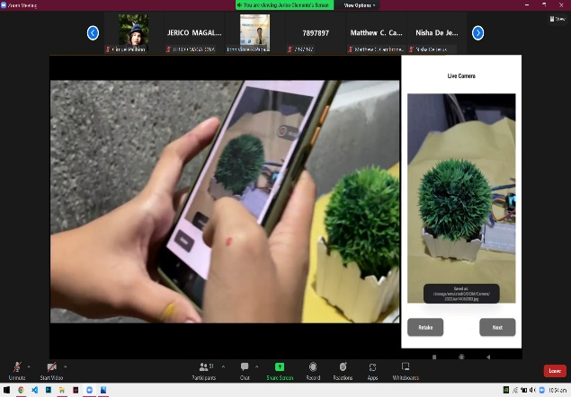 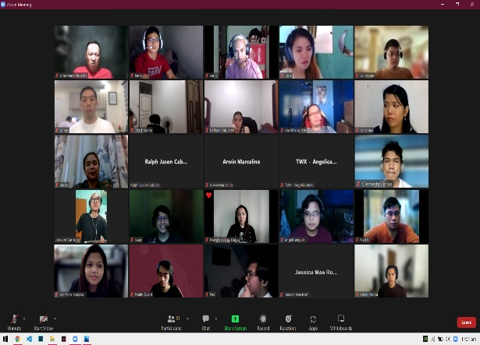

*Conducted Zoom Meeting for Demonstration of Machine and Mobile Application*

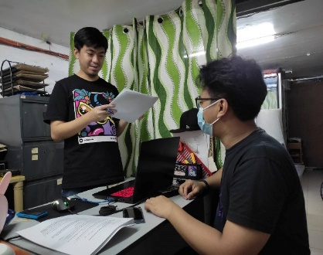 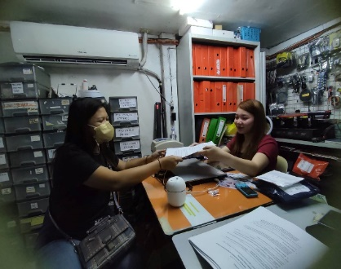

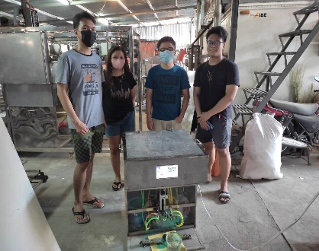 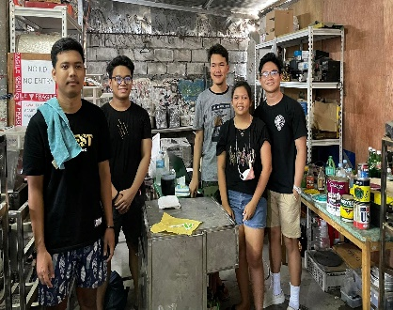

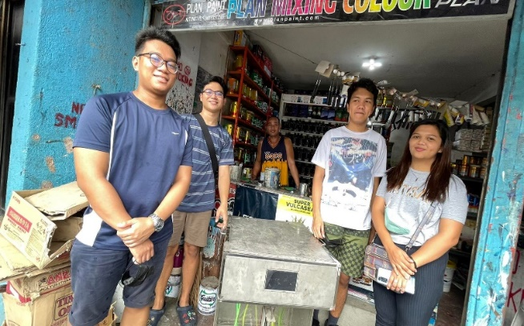

*Conducted Face to Face Demonstration and Survey*

**Appendix 14: Zoom Invitation Letter**

A colorful day!

We are 4th year graduating students from the Polytechnic University of the Philippines – Manila. We would like to invite you to attend our Online Conference where we will virtually demonstrate the features and functions of our Paint Mixing Machine and Mobile Application named RoboMIX.

RoboMIX application makes use of Bluetooth connectivity to communicate with the RoboMIX machine. Our machine accepts input from both the application and its built-in controls. After receiving the input, the machine will mix the corresponding paint color.

The conference will make use of Zoom online meeting as its platform. Zoom meeting details are as follows:

Topic: Paint Mixing Machine and Mobile Application Conference

Time: June 30, 2022 9:00AM Beijing, Shanghai

Join Zoom Meeting

[https://us04web.zoom.us/j/71547829760?pwd=TJg49Wj_4zXu-Cz1J_Jf219oQxLREd.1](https://us04web.zoom.us/j/71547829760?pwd=TJg49Wj_4zXu-Cz1J_Jf219oQxLREd.1&fbclid=IwAR0Z1Ox3exA9UqfmIT5NEevS5dfexLt-JRt-1PnG9K1TQqIEC16G7TECJnM)

Meeting ID: 715 4782 9760

Passcode: k2g8u9

**Appendix 15: Cronbach’s Alpha Calculation**

|  |  |  |  |  |
| --- | --- | --- | --- | --- |
| **Variance of values** | **Sum of Variances** | **k** | **alpha** | **Interpretation** |
| 7.2655 | 2.4954 | 5 | 0.8207 | Highly Reliable |

**Appendix 16: Nextion LCD User Interface**

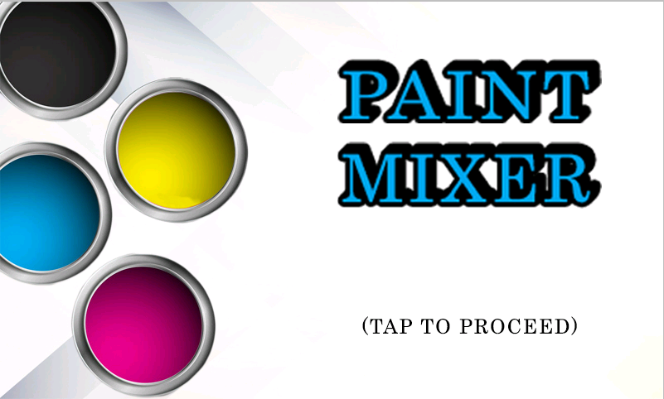 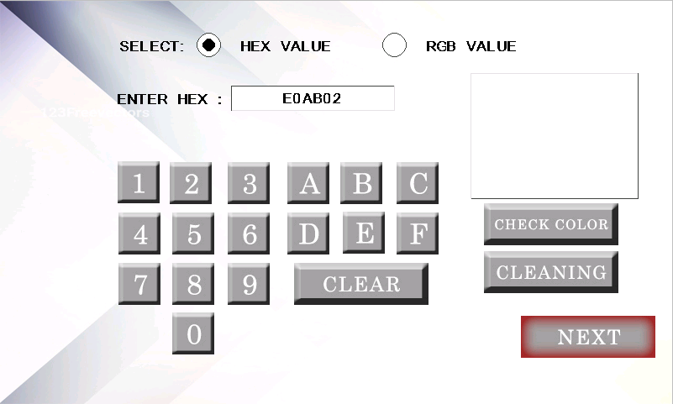

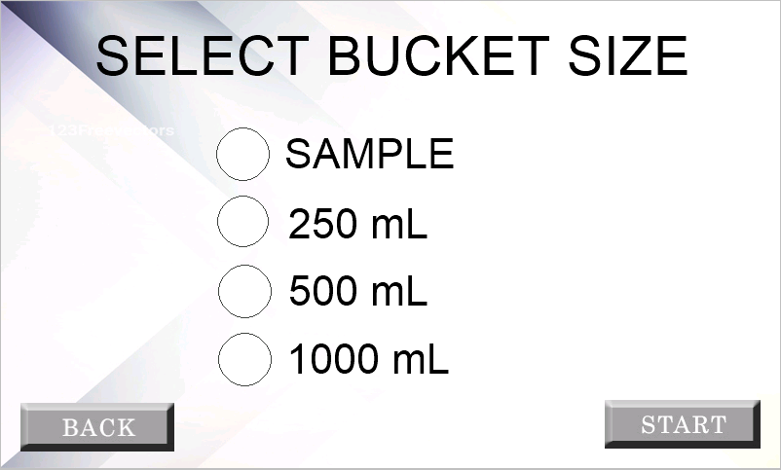 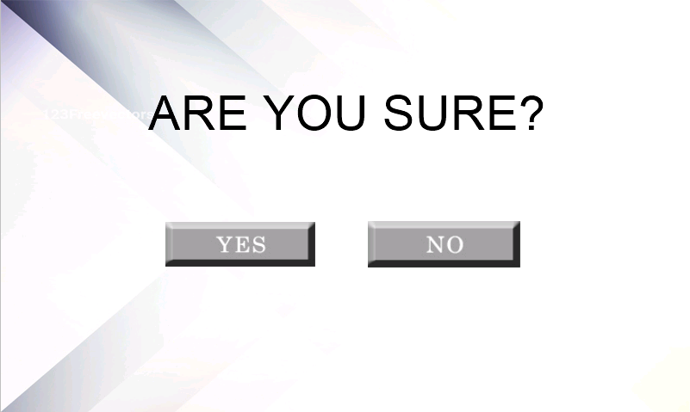

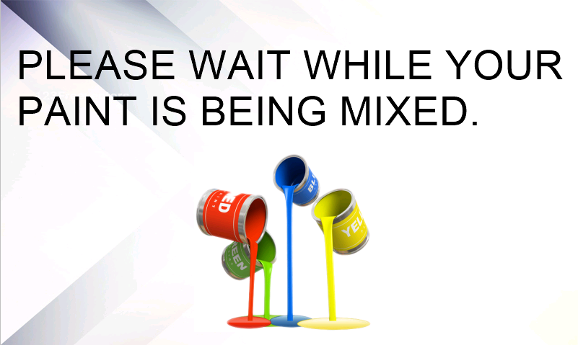 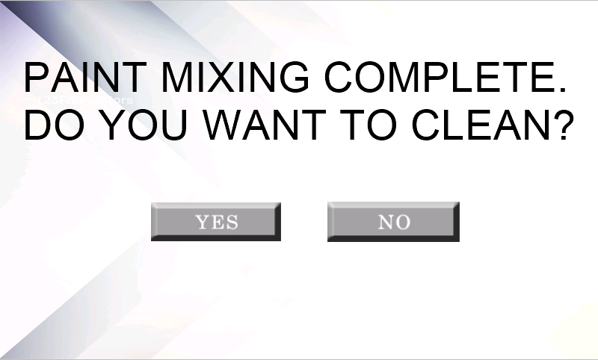

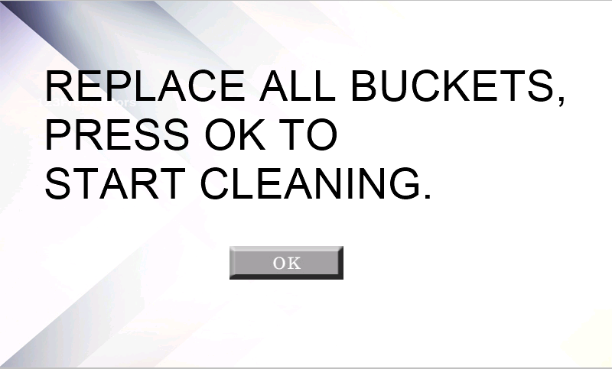 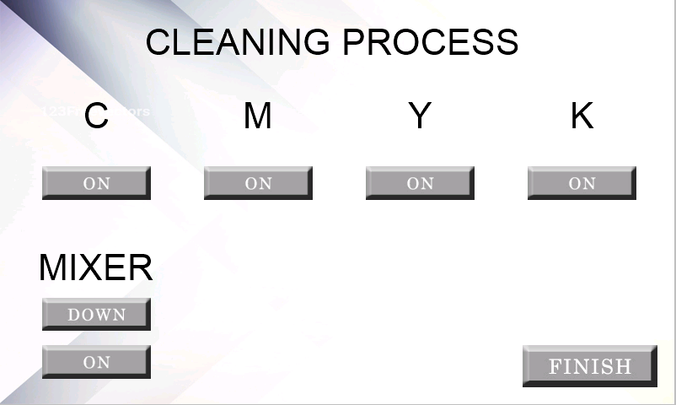

** **

**Author’s Note**

|  |  |
| --- | --- |
|  | **Jerico M. Clemente**  He is a 4th Year Computer Engineering Student. He is also a member of PUP – Association of Concerned Computer Engineering Students for Services of School Year 2021 – 2022. |
|  | **Aldrin O. Dizor**  He is a 4th Year Computer Engineering Student and a PIO Valenzuela Scholar. He is the Batch President of School Year 2021-2022 and the Class President of his class. He is also a member of PUP – ACCESS of School Year 2021 – 2022. |
|  | **Marife G. Gajelan**  She is a 4th Year Computer Engineering Student. She is the Vice President of Student Relations of PUP – Association of Concerned Computer Engineering Students for Services of School Year 2021 – 2022. |
| No description available. | **Joven R. Sabangan**  She is a 4th Year Computer Engineering Student. He is the Executive Vice President of PUP – Association of Concerned Computer Engineering Students for Services of School Year 2021 – 2022. |